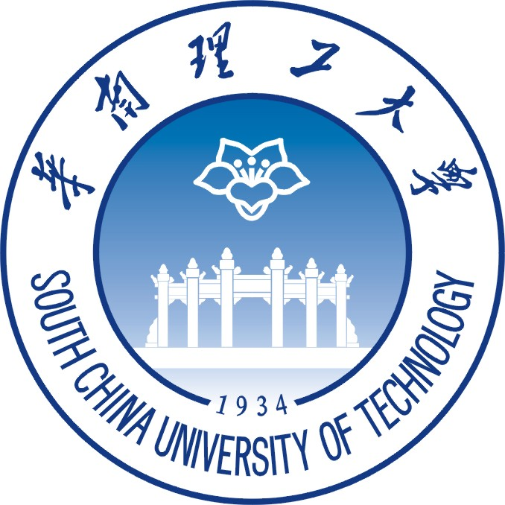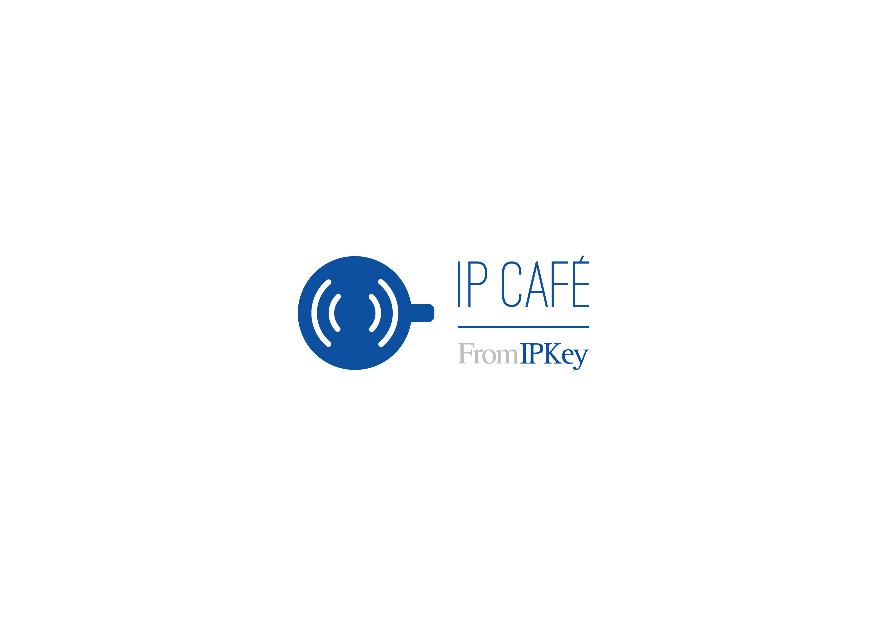**IP Café in Partnership with South China University of Technology IP Café** —与华南理工大学合作

Thursday, 11th June 2015, South China University of Technology, 15:00-18:30

2015 年 6 月 11 号, 星期四,15:00- 18: 30 华南理工大学

University Town International Hotel, Nan Hua Conference Room, SCUT Dong er Road, Higher Education Mega Center Of Guangzhou China

华工大学城中心酒店**南华厅**, 广东省广州市天河区广州大学城东二路华南理工大学

English & Chinese with simultaneous interpretation

提供中英同声传译

IP Key presents ***IP Café*** - A series of open discussions addressing contemporary intellectual property issues in the European Union and China. These debates feature key experts from the European Union and China discussing the issues that shape today’s IP landscape. Together they share thought provoking ideas on how to improve the development of China’s IP environment as China continuously moves to an innovation led economy.

**IP Key** 举办的 ***IP Café*** 是关于中国和欧盟当下知识产权问题的开放性讨论。 该活动邀请双方的知识产权专家探讨构成当今知识产权版图的重要问题。 随着中国逐渐转为一个以创新为主导的经济体,他们将就如何改善中国的知识产权环境讨论与分享自己的观点。

**Court Enforcement of Trade Secrets and Unfair Competition Law**

***IP Café*** will be held in partnership with South China University of Technology and will focus on Court Enforcement of Trade Secrets and Unfair Competition Law***.*** IP Key and SCUT bring together key experts from the European Union and China, asking them to provide insights on the judicial protection of trade secrets and anti-unfair competition law, in the light of the new scenario of Chinese IP Courts, drawing comparisons between EU – in particular Netherlands and Spain – on the one side and China on the other.

**商业秘密和不正当竞争的司法保护**

本次***IP Café*** 由IP Key 和华南理工大学合作举办，重点讨论商业秘密与不正当竞争的司法保护。IP Key与华南理工大学将与主要中欧相关领域专家齐聚一堂, 共同讨论商业秘密的司法保护与反不正当竞争法的适用，并在中国新近设立知识产权专门法院的背景下， 比较中国和欧盟（尤其是西班牙与荷兰）商业秘密法及反不正当竞争法的异同。

**Agenda 议程**

|  |  |
| --- | --- |
| 15:00-15:20 | Welcome & Registration 欢迎和签到 |
| 15:20-15:30 | Opening remark 开场词 |
| 15:30-16:40 | Introduction of panelists and speakers, Presentations by Prof. Xie Huijia and Former Deputy Judge Ou Xiuping & Panel Discussion 嘉宾介绍，谢惠加教授和原副庭长欧修平先生演讲，和专题讨论 |
| 16:40-17:00 | Coffee Break 茶歇 |
| 17:00-18:00 | Q&A and Panel Discussion 问答和讨论 |
| 18:00-18:30 | Closing 结束 |

**Panelists** 嘉宾

|  |  |
| --- | --- |
| **Edger Frank Brinkman**  *Senior Judge of The Hague IP Court*  **伊哲•布林克曼**  海牙知识产权法院 | **OU Xiuping**  *Former Deputy Chief Judge at IP Court of Guangdong High People's Court*  **欧修平**  原广东省高级人民法院知识产权庭副庭长 |
| **Angel Galgo Peco**  *Section President of Madrid Commercial Court*  **安格尔•嘉格尔•佩科**  马德里商业法院分院院长 | **ZHANG Yongzhong**  *Professor, Associate Dean at SCUT Law School, Deputy Chief Judge at Second Civil Court of Guangzhou Intermediate Court*  **张永忠**  华南师范大学法学院教授，副院长  广州市中级人民法院民二庭副庭长 |
| **Davide Follador**  *Long Term Expert - IP Key*  **付大伟**  中欧知识产权项目长期专家 | **XIE Huijia**  *Professor, Dean Assistant at SCUT Law School*  **谢惠加**  华南理工大学法学院 教授，院长助理 |
| **GUAN Yonghong**  *Professor, Director of IP Department in SCUT*  **关永红**  华南理工大学知识产权系教授，系主任 | **LIU Hanxia**  *Associate Professor at SCUT, Assistant Chief Procurator at Tianhe District Procuratorate in Guangzhou*  **刘汉霞**  华南理工大学法学院副教授  广州市天河区检察院助理检察长 |
| **YANG Xiongwen**  *Professor at SCUT Law School*  **杨雄文**  华南理工大学法学院教授 | **YIN Jiguo**  *Associate Professor at SCUT Law School*  **殷继国**  华南理工大学法学院副教授 |

|  |
| --- |
|  |



**For more information please contact us: info@ipkey.org, www.ipkey.org**

IP Key is co-financed by the European Union and the Office for Harmonization in the Internal Market (OHIM) under the framework of the new EU-China Cooperation. It is implemented by the Office for Harmonization in the Internal Market (OHIM) in cooperation with European Patent Office (EPO). The contents of this document are the sole responsibility of the project implementation team and can in no way be taken to reflect the views of the European Union. Content may be reproduced and disseminated as long as it is attributed to the original source.

IP Key项目由欧洲联盟与欧盟内部市场协调局（OHIM）在新的中欧合作框架下共同资助。该项目由欧盟内部市场协调局与欧洲专利局（EPO）合作实施。本出版物是在欧盟的支持下制作，但本出版物的内容是项目实施小组的单独职责，决不反映欧盟的观点。内容可转载，但须注明原出处。

