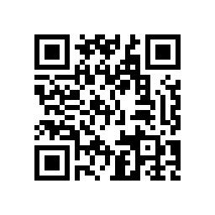 | 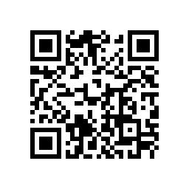
1016参访前沿软物质学院公共仪器平台报名 | 1017参访微纳电子中心报名
Session 1: Visit to the Public Instrumentation Platform of the School of Emergent Soft Matter | Session 2: Visit to the Micro & Nano Electronics Platform

