Conference Topics & Invited speakers

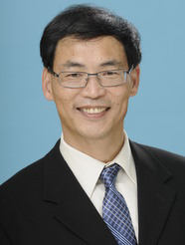**Session 1: Metabolism and Nutrition of Lipids & Lipidomics**

1. **Xianlin Han, Ph.D.**

Professor, Center for Metabolic Origins of Disease,

Sanford Burnham Prebys Medical Discovery Institute，United States

**Research Interests**: Shotgun Lipidomics Technology; Cellular Lipidome; High Throughput and Bioinformatics.

1. **Yann Gibert, Ph.D**

Senior Lecturer, Head of the Metabolic Genetic Diseases Laboratory,

School of Medicine, Faculty of Health, Deakin University, Australia.

**Research Interests:** Metabolism; Nuclear receptors biology; Zebrafish embryogenesis; Chemical Biology.

1. 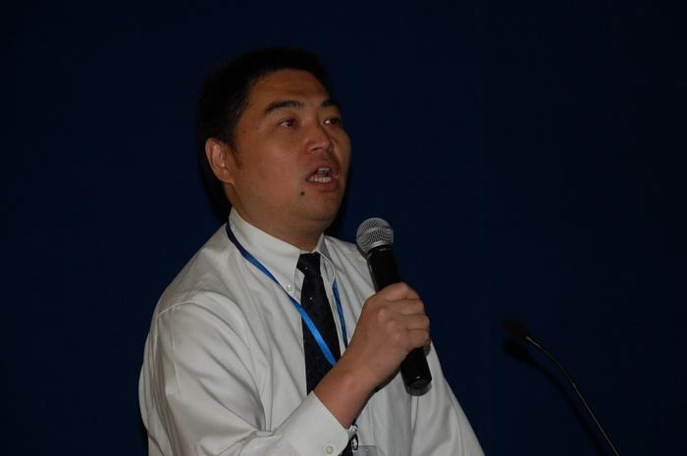**Ying Yu，Ph.D.**

Professor fellowship of ‘Yangzte River Scholar’,

Vice Director of Tianjin Medical University,

Head of phospholipid metabolism and cardiovascular disease research group, Chinese Academy of Sciences

**Research Interests:** COX, EPA, DHA and prostaglandin products on cardiac remodeling and vascular injury; the role of prostaglandins and their receptors in glycolipid metabolism and diabetic vascular disease; molecular mechanism and rapid detection of chemical pollutants in food.

1. 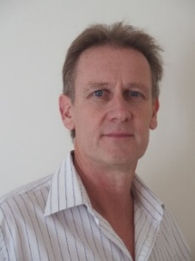**Peter Meikle, Ph.D.**

Associate Professor, NHMRC Senior Research Fellow,

Obesity and Diabetes Program Leader, Head of the Metabolomics Laboratory,

Baker Heart and Diabetes Institute, Australia.

**Research Interests:** Dyslipidemia and altered lipid metabolism associated with obesity, diabetes and cardiovascular disease and its relationship to the pathogenesis of these disease states.

1. **Xu Lin, Ph.D.**

Professor, Principle Investigation of 863 Program

Director of Key Laboratory of Nutrition and Metabolism, CAS

Chairwomen of Fundamental Nutrition Branch, China Nutrition Society,

**Research Interests:** Molecular epidemiological study on relationship between the main gene and environmental factors Chinese and risk of obesity, metabolic syndrome, type 2 diabetes and other metabolic diseases; Study on relationship of metabolic disease and dietary metabolism based on multi-omics.

1. **Makoto Arita, Ph.D.**

Team Leader, Laboratory for Metabolomics,

RIKEN Center for Integrative Medical Sciences, Yokohama, Japan,

Professor, Division of Physiological Chemistry and Metabolism,

Keio University Faculty of Pharmacy, Tokyo, Japan.

**Research Interests:** Development and application of untargeted lipidomics to discover novel link between lipid metabolism and biological phenotypes.

1. 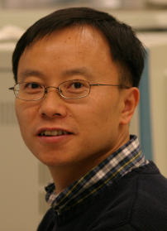**Huiyong Yin, Ph.D.**

Professor, Director of the MS Center for Nutrition and Metabolism Analysis,

Shanghai Institute of Health, Chinese Academy of Sciences.

**Research Interests:** Application of chemistry, molecular/cell biology, and animal models to study free radical mechanism of lipid oxidation and its role in human nutrition and diseases; development of mass spectrometry techniques including lipidomics, metabolomics, and proteomics to study lipid metabolism; exploration of nutritional intervention to prevent some nutrition-related human diseases.

1. 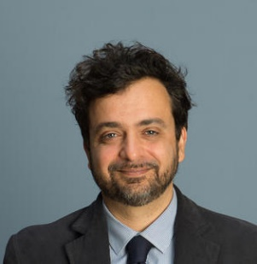**Giovanni Turchini, Ph.D**

Professor, School of Life and Environmental Sciences，

Deakin University, Australia.

**Research Interests:** Nutrition (animal and human); Food quality; Lipids and fatty acid metabolism; Fats and Fatty acid biochemistry; Aquaculture; Fish nutrition; Fish oil replacement in aquaculture; Novel ingredients for aquafeed; Seafood quality and traceability; Ethical issues encountered in the fisheries and aquaculture sectors.

**Session 2: New Resources of Fats and Oil & Application of Enzyme Engeering**

1. **Mitsutoshi Nakajima, Ph.D.**

Professor, Faculty of Life and Environmental Sciences,

University of Tsukuba, Japan

**Research Interests:** Food Engineering, Emulsion Science and Microchannel Emulsifiction, Membrane Separation, Food Micro/Nano-Structure, Nanoparticles as well as Microalgae Biomass Processes.

1. 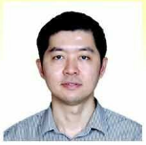**Tan Chin Ping, Ph.D.**

Head/ Professor of Department of Food Technology,

Faculty of Food Science & Technology,

University Putra, Malaysia.

**Research Interests:** Fats and oils chemistry and technology, food emulsion, food nanotechnology, food processing, palm oil.

1. 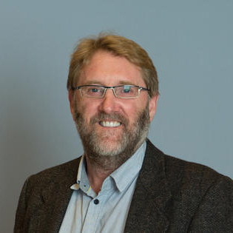**Colin Barrow, Ph.D.**

Alfred Deakin Professor and Chair in Biotechnology

School of Life & Env. Sciences,

Deakin University, Australia

**Research Interests:** Omega-3 Biotechnology and Bioprocessing; Lipases and lipases modification; Amyloid fibres and nanomaterials.

1. 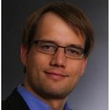**Robert Kourist, Ph.D**

Professor, Head of Institute of Molecular Biotechnology,

TU Graz, Austria

**Research Interests:** [Enzyme Engineering](https://cn.linkedin.com/topic/enzyme-engineering?trk=pprofile_topic); [Molecular Modeling](https://cn.linkedin.com/topic/molecular-modeling?trk=pprofile_topic); [Molecular Biology](https://cn.linkedin.com/topic/molecular-biology?trk=pprofile_topic); [Biotechnology](https://cn.linkedin.com/topic/biotechnology?trk=pprofile_topic); [Biocatalysis](https://cn.linkedin.com/topic/biocatalysis?trk=pprofile_topic)**.**

1. 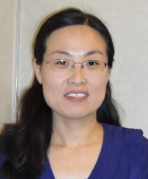**Yonghua Wang, Ph.D.**

Professor Fellowship of ‘Zhujiang Scholar’,

Associate Dean of School of Food Science and Engineering,

South China University of Technology, P.R. China

**Research Interests:** Enzyme and Lipids Biocatalysis.

1. 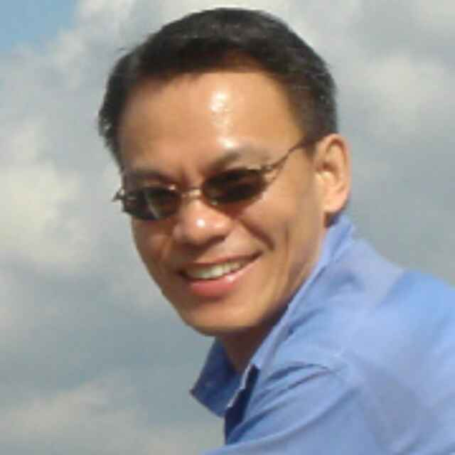**Charles C. Liu, Ph.D.**

CEO&CTO, ASPEC Technologies Limited.

**Research Interests:** Application of Mass Spectrometry in Lipidomics and Lipids Analysis.**ISLSB 2017 Program Preview·Guangzhou China**

|  |  |  |  |  |
| --- | --- | --- | --- | --- |
| **DATE** | | **TIME** | | **CONTENTS** |
| **April 27** | | 14:00-22:00 | | **Registration**   * Honder International Hotel |
| April 28 (First Day) | | | | |
| **April 28**  **A.M** | | **08:30**  **-**  **09:00** | | **Opening Remarks** |
| **Session 1: Metabolism and Nutrition of Lipids & Lipidomics** | | |
| 09:00-09:25 | | Xianlin Han, Ph.D.  Professor, Center for Metabolic Origins of Disease,Sanford Burnham Prebys Medical Discovery Institute，United States. |
| 09:25-09:50 | | Yann Gibert, Ph.D  Senior Lecturer, Head of the Metabolic Genetic Diseases Laboratory, School of Medicine, Faculty of Health, Deakin University, Australia. |
| 09:50-  10:15 | | Ying Yu，Ph.D.  Professor fellowship of ‘Yangzte River Scholar’,Vice Director of Tianjin Medical University,Head of phospholipid metabolism and cardiovascular disease research group, Chinese Academy of Sciences |
| **10:15**  **-**  **10:30** | | **Tea Break** |
| 10:30-  10:55 | | Peter Meikle, Ph.D.  Associate Professor, NHMRC Senior Research Fellow, Obesity and Diabetes Program Leader,Head of the Metabolomics Laboratory, Baker Heart and Diabetes Institute, Australia. |
| 10:55-  11:20 | | Xu Lin, Ph.D.  Professor, Principle Investigation of 863 Program  Director of Key Laboratory of Nutrition and Metabolism, Chinese Academy of sciences, Chairwomen of Fundamental Nutrition Branch, China Nutrition Society, |
| 11:20-11:45 | | Makoto Arita, Ph.D.  Team Leader, Laboratory for Metabolomics,RIKEN Center for Integrative Medical Sciences, Yokohama, Japan,  Professor, Division of Physiological Chemistry and Metabolism,Keio University Faculty of Pharmacy, Tokyo, Japan. |
| **11:45**  **-**  **14:30** | | **Lunch** |
| **April 28**  **P.M** | | 14:30-14:55 | | Huiyong Yin, Ph.D.  Professor, Director of the MS Center for Nutrition and Metabolism Analysis,  Shanghai Institute of Health, Chinese Academy of Sciences. |
| 14:55-15:20 | | Giovanni Turchini, Ph.D  Professor, School of Life and Environmental Sciences，Deakin University, Australia. |
| **Session 2: New Resources of Fats and Oil & Application of Enzyme Engeering** | | |
| 15:20 - 15:45 | | Mitsutoshi Nakajima, Ph.D.  Professor, Faculty of Life and Environmental Sciences, University of Tsukuba, Japan |
| 15:45 - 16:10 | | Tan Chin Ping, Ph.D.  Head/ Professor of Department of Food Technology, Faculty of Food Science & Technology, University Putra, Malaysia. |
| **16:10**  **-**  **16:20** | | **Tea Break** |
| 16:20**-** 16:45 | | Colin Barrow, Ph.D.  Alfred Deakin Professor and Chair in Biotechnology, School of Life & Env. Sciences,  Deakin University, Australia |
| 16:45- 17:10 | | Robert Kourist, Ph.D  Professor, Head of Institute of Molecular Biotechnology,  TU Graz, Austria |
| 17:10- 17:35 | | Yonghua Wang, Ph.D.  Professor Fellowship of ‘Zhujiang Scholar’,  Associate Dean of School of Food Science and Engineering, South China University of Technology, P.R. China |
| 17:35- 18:00 | | Charles C. Liu, Ph.D.  CEO&CTO, ASPEC Technologies Limited. |
| **April 28** | | **18:00**  **-**  **20:30** | | **Dinner and Party** |
| April 29 (Second Day) | | | | |
| **April 29** | 09:00-  11:50 | | **Academic Trip** | |
| **12:00**  **-**  **14:00** | | Lunch | |
| 14:00-  18:00 | | **Free time** | |
| **18:30**  **-**  **20:30** | | Finale Dinner and Party | |

**Registration Form**

|  |  |  |  |
| --- | --- | --- | --- |
| Name | Institute/Company | Phone Number | Need / Not need accommodation? |
|  |  |  |  |
|  |  |  |  |
|  |  |  |  |
|  |  |  |  |
|  |  |  |  |

Please return the Registration Form to[lpzhan@scut.edu.cn](mailto:lpzhan@scut.edu.cn) before April 15th, 2017 or through QQ5028796.

Abstracts and posters should be submitted before April 15th, 2017.