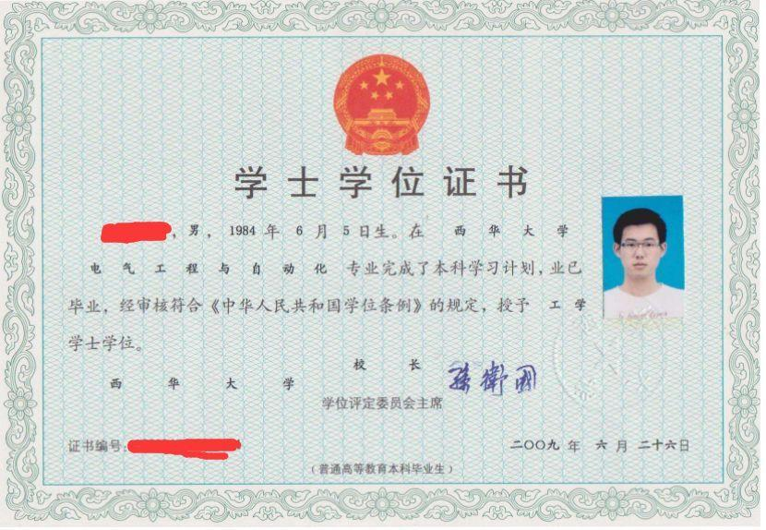

Bachelor's Degree Certificate

Xxxx, male, born in 5th, June, 1984, completed the undergraduate study plan in the Electrical Engineering and Automation major of Xihua University. He has graduated and been audited to comply with the requirements of the "Regulations on Degrees of the People's Republic of China", Award a Bachelor of Engineering.

The president and chairman of degree evaluation committee of Xihua University: xxx

Diploma Number: 123456 26th, June, 2009