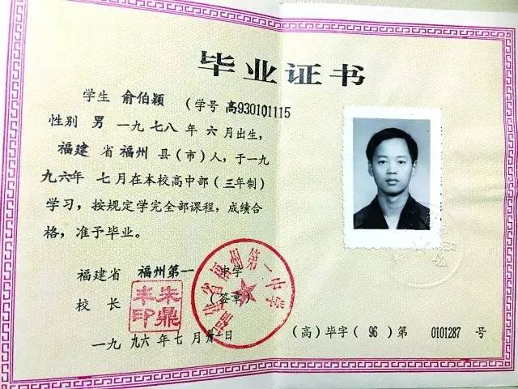

**Diploma**

Student xxx (student number: 123456), male, born in June, 1978, from Fuzhou county (city) in Fujian province, studied in this senior high school (three-year) in July 1996 and finished all courses in accordance with the regulations, and passed the tests. Permit to graduate.

Fuzhou No.1 Middle School, Fujian province.

31th, July, 1996. Diploma Number: 0101287