Microstructure and properties of nanostructured WC-Co hardmetals prepared by mechanical alloying

F. L. Zhang, L. Z. Ouyang, M. Q. Zeng, C. Y. Wang and M. Zhu

1.Background
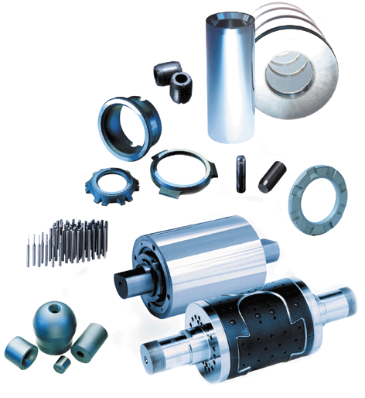
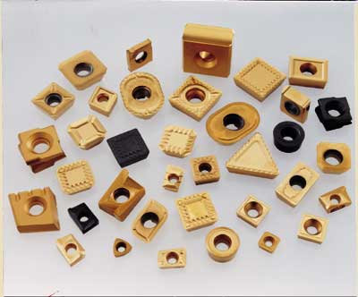
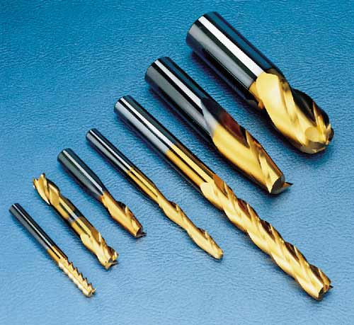
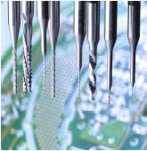

The hardness and strength of hardmetals increase with the decreasing of the grain size of WC, as described by the Hall-Petch relationship and nanocrystalline WC-Co hardmetals have a lot of important applications
σ=σ₀ + Kd^{-1/2}

Dependence of hardness and transverse rapture strength (TRS) of WC-Co hardmetals with different grain grade on the content of Co
Applications of sub-micron and nanocrystalline WC-Co hardmetals

2. Manufacturing process of WC-Co hardmetal
Tungsten carbide

WC
other carbides
TiC, TaC
Binder metal
Co(Ni)

Wet milling
with lubrication

Drying
Isostatic pressing

Die pressing
Extrusion

Delubrication, Presineting

Sintering(HIP)

Sintered blank
Finishing
3. Nanostructured WC-Co composite powder prepared
by high energy ball milling
Ⅰ Microstructure of WC-Co composite after 10h of milling

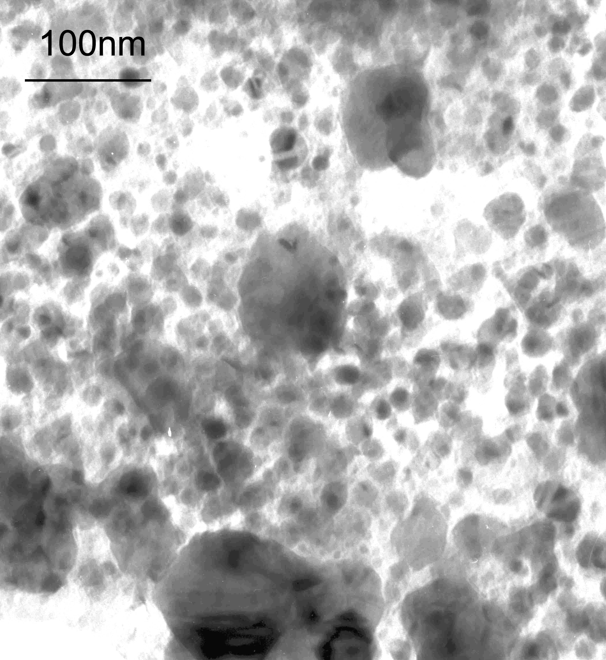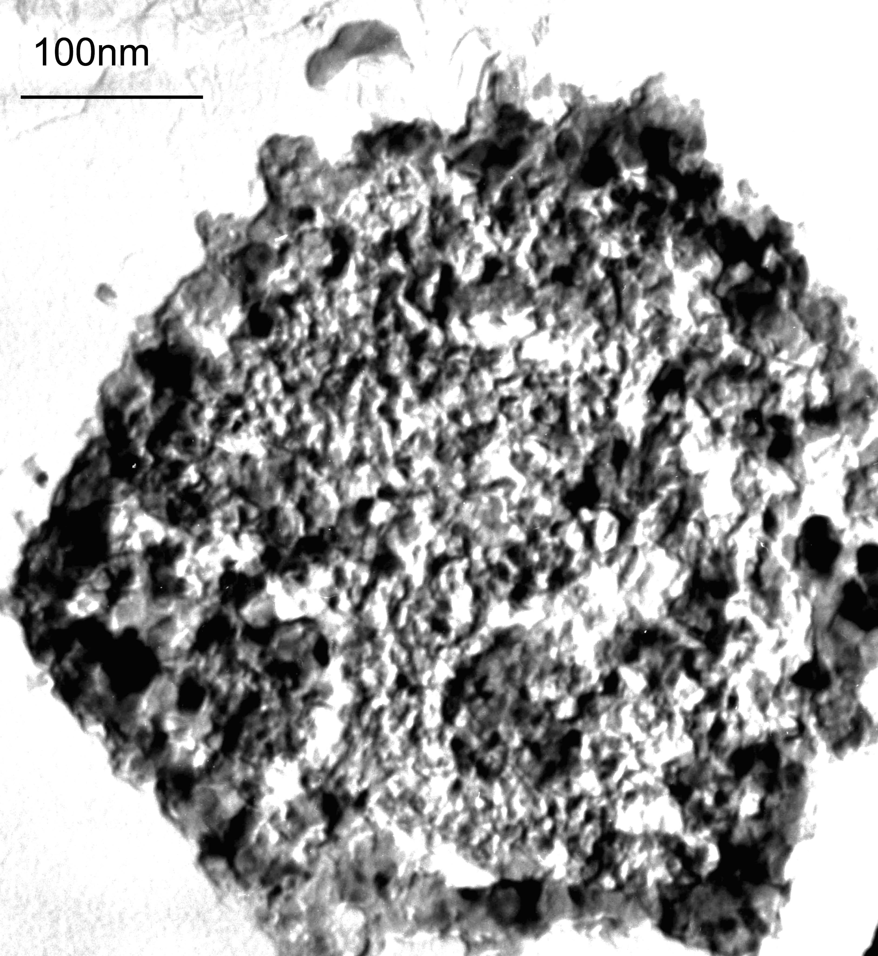
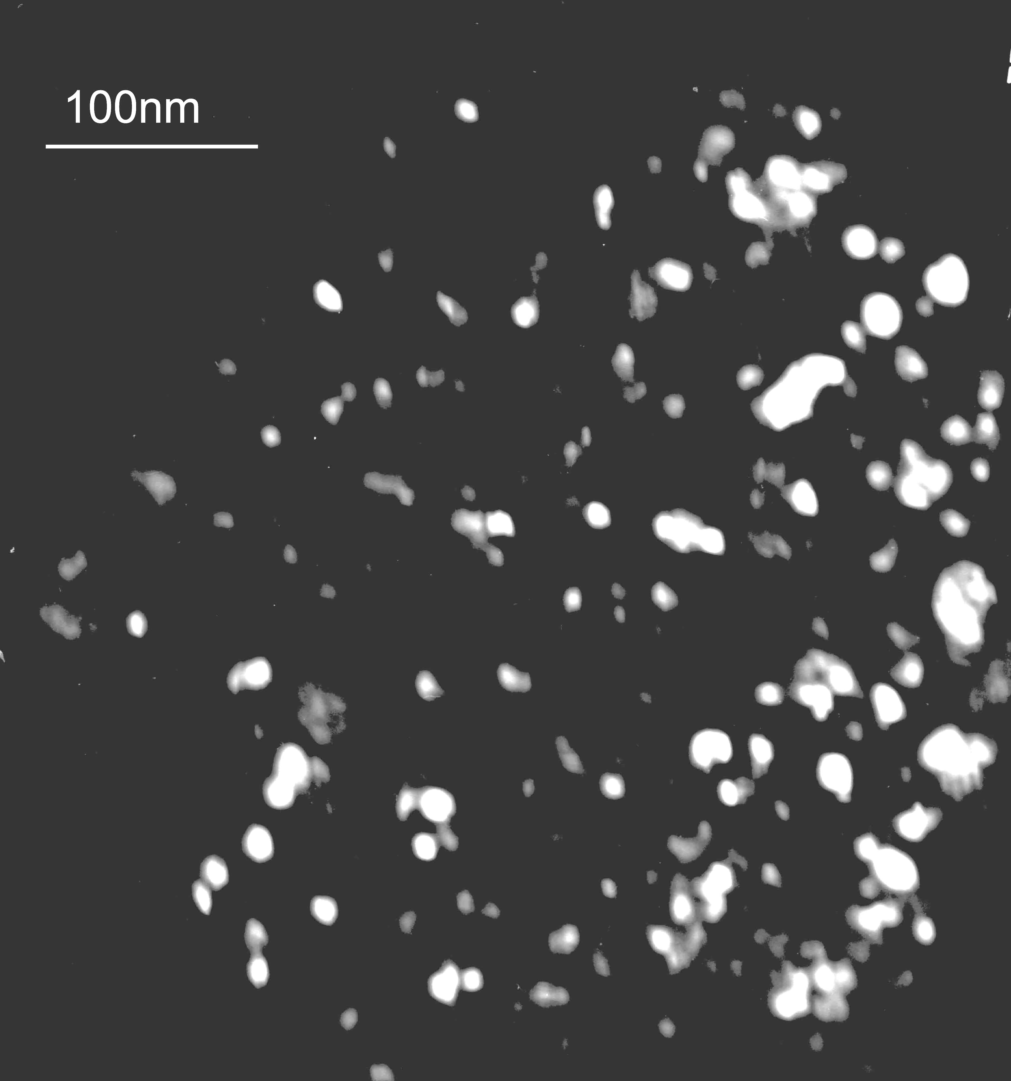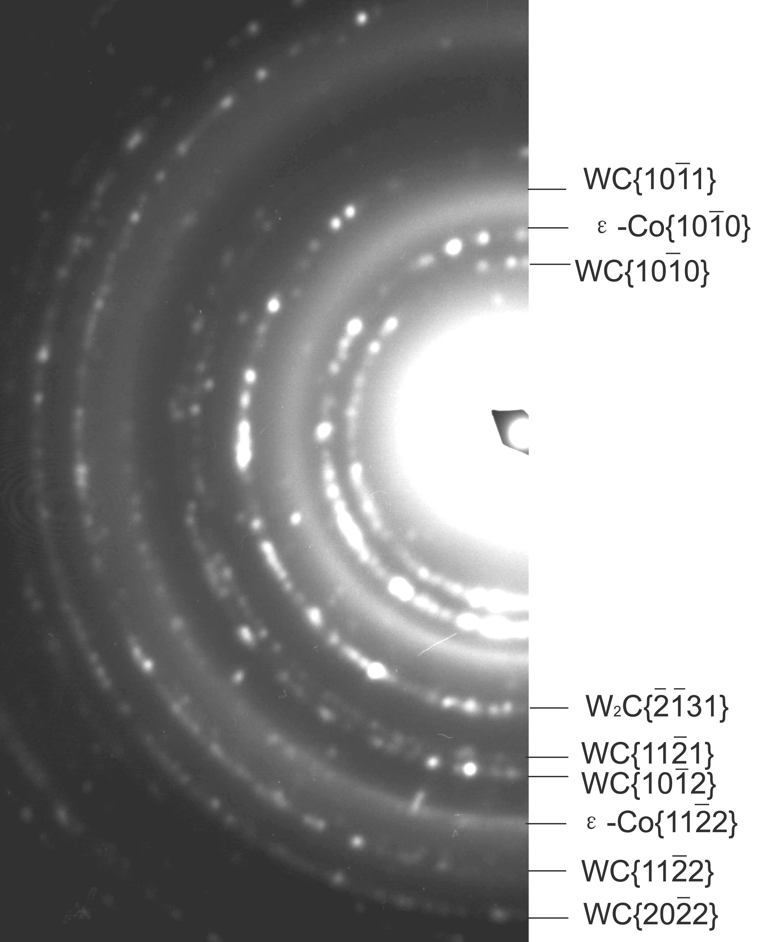

a
b
c
d

TEM images of WC-10Co composite prepared by 10h of milling: bright field image(a), (b), dark field image(c) which corresponds to (b), and electron diffraction patterns(d). Dark field image(c) was obtained with the objective aperture circled on a section of WC{$\text{10}\overline{1}0$} diffraction halo.

X-ray diffraction patterns of raw WC-10Co powder (a) and WC-10Co composite powder obtained by 10h milling (b)

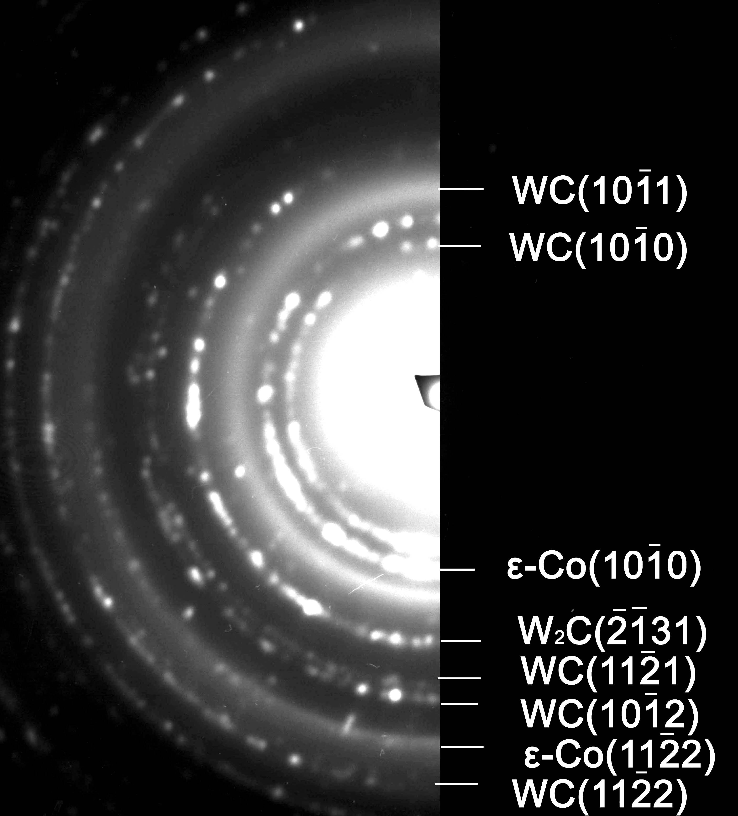
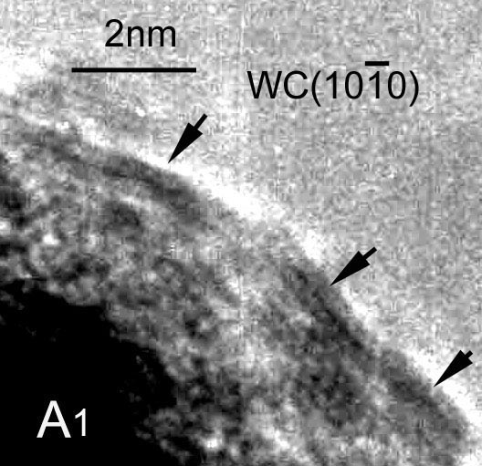
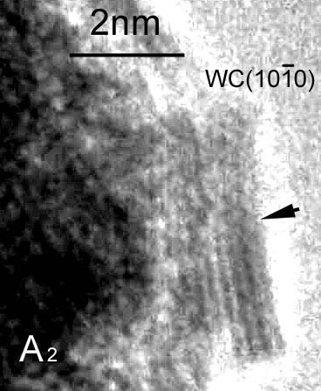

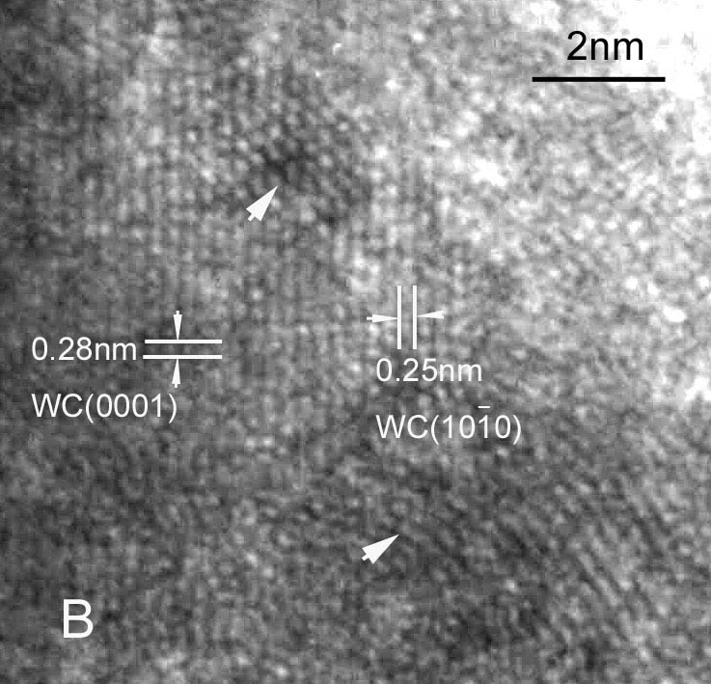

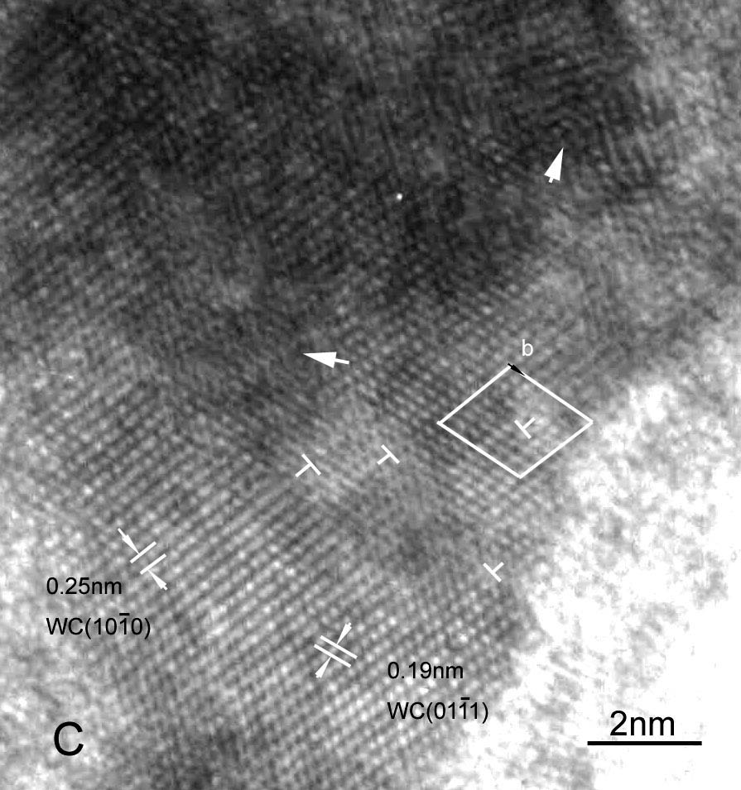

High resolution electron microscopy image on the rim of WC particle in WC-10Co composite prepared by 10h milling
Enlarged images of A₁,A₂,B and C regions in left figure: region A₁and A₂ contain the （$\text{10}\overline{1}0$）straight surface; region B contains the severe lattice distortion; in region C the dislocation 1/3[$\text{11}\overline{2}0$] is located.

Ⅱ Microstructure of WC-Co composite after 90h of milling
Grain size of WC can be reduced to 5-8nm after 90h of milling
(doping with VC and Cr₃C₂ have no obvious effect on the grain size reduction in the milling)

Grain size reduction of WC in according with the increasing of milling time in WC-10Co composite powder when doping with different contents of VC and Cr₃C₂ in the ball milling

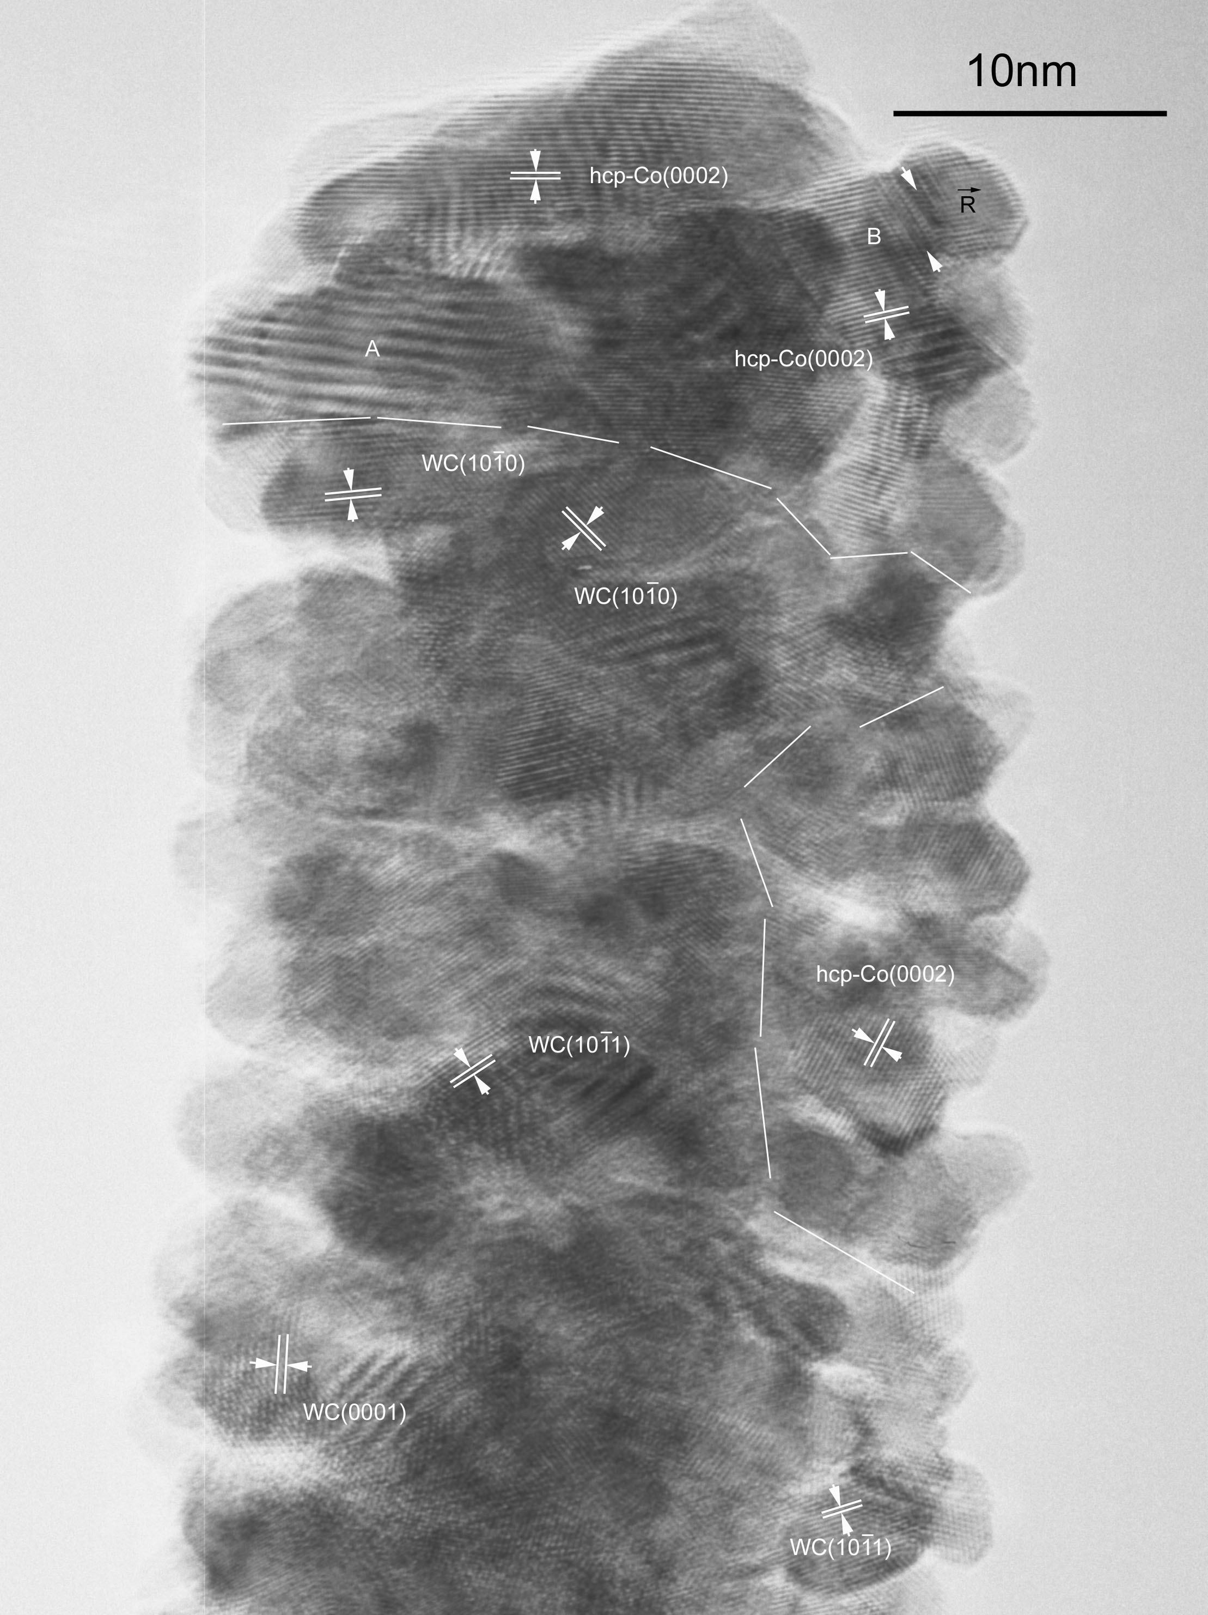

HRTEM image of WC-Co composite particles prepared by 90h of milling
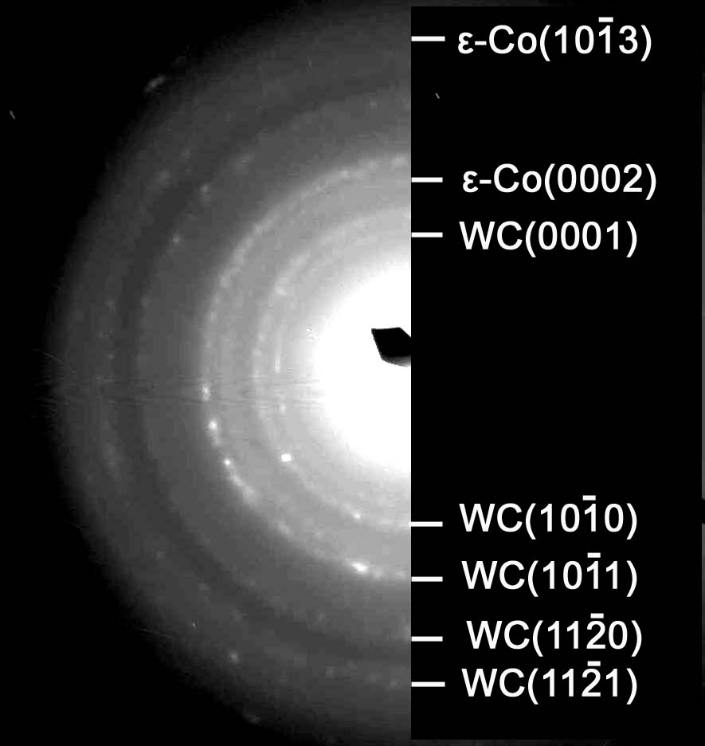
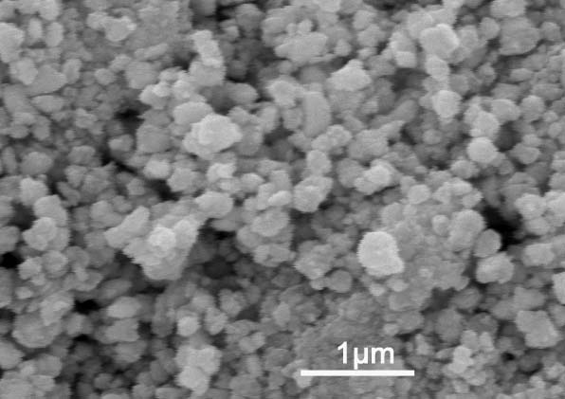
SEM image of naostructured WC-Co composite powder prepared by 90h of milling

(a)

(b)
Schematic illustration of the evolution of composite particles (a) and nanocrystalline structures (b)of the WC-10Co composite by high energy ball milling

4. Microstructure of WC-Co hardmetal sintered from nanostructured WC-Co composite powder prepared by high energy ball milling

a
b
c
d
e
f
Doping with VC can more effectively inhibit the grain growth of WC than Cr₃C₂ during the sintering

SEM images of n-WC-10Co vacuum-sintered at 1380℃for 60min with different content of VC和Cr₃C₂: a)non-doped, b)0.6VC-0.6Cr₃C₂, c)1.2 Cr₃C₂,d)1.2VC, e) 1.5VC-1.5Cr₃C₂-0.2CeO₂, f)enlarged image of e)

b
a
d
c

SEM images of hardmetals sintered from n-WC-10Co powder doped with 1.2VC（a, b）and 1.5VC-1.5Cr₃C₂-0.2CeO₂ (c, d) obtained by sintering at 1380℃ for 30min(a, c) and 60min(b, d)

Vicker hardness and K_{IC} of hardmetal obtained by gas pressure sintering and vacuum sintering of n-WC-10Co powder with different content of VC and Cr₃C₂ at 1380℃for 60min

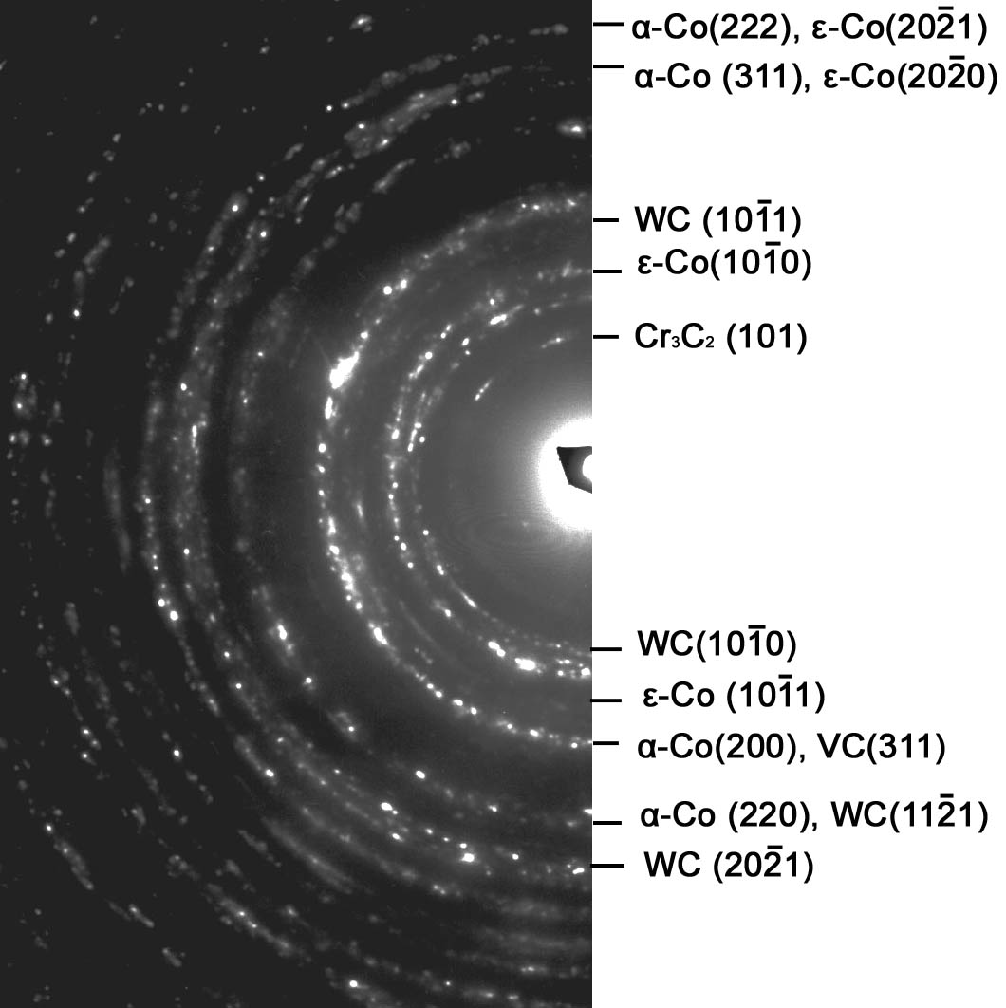
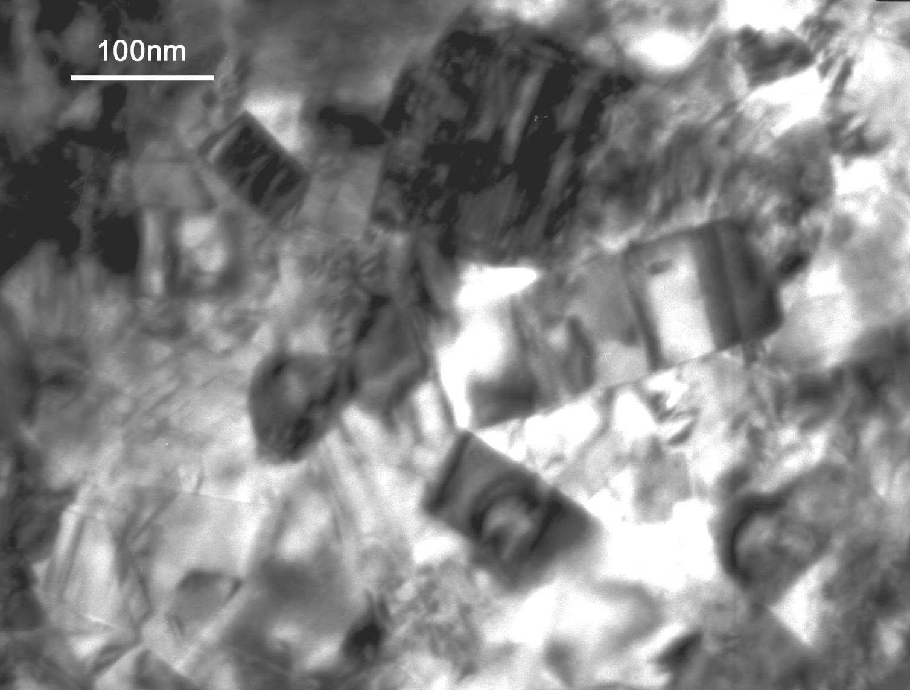
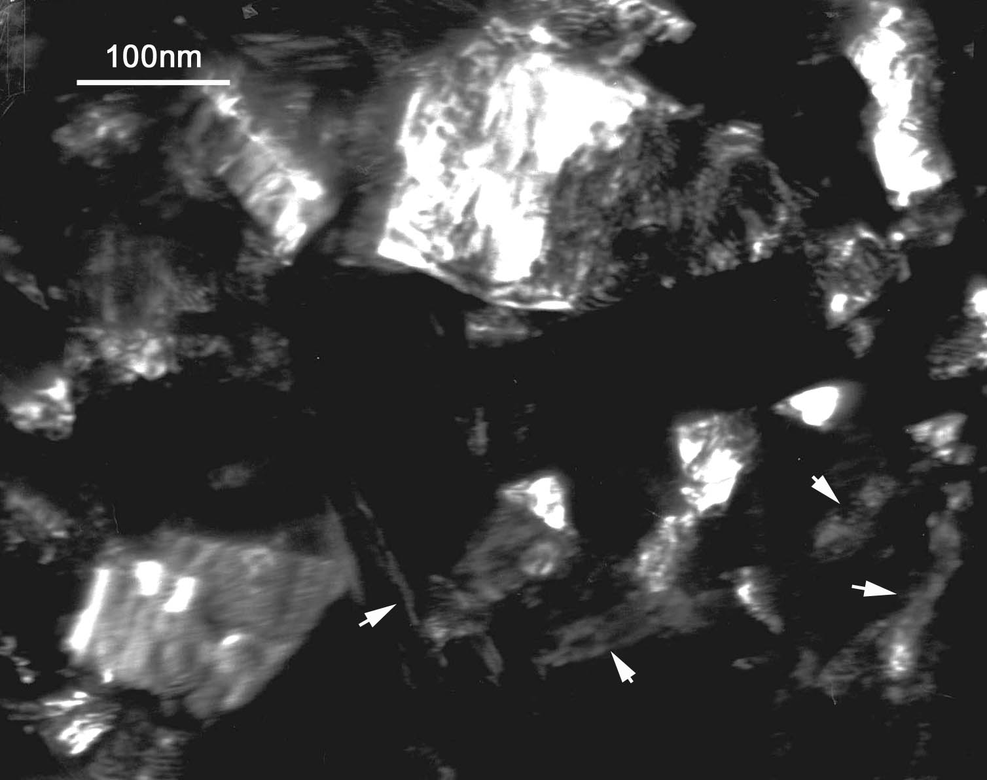

a
b
c
b
c
TEM images of n-WC-10Co doping with 1.5VC-1.5Cr₃C₂-0.2CeO₂ (a, b) obtained by pressure sintering at 1380℃ for 60min：a) bright field image, b)dark field image, c) electron diffraction pattern. Dark field image (b) is obtained with the objective aperture circled on a section of WC{$\text{10}\overline{1}0$} andε-Co($\text{10}\overline{1}0$) diffraction halos.

