Phase transformation and properties of porous TiNi shape memory alloys fabricated by capsule-free hot isostatic pressing

B. Yuan, X. P. Zhang, K. Wang, M. Q. Zeng, C. Y. Chung* and M. Zhu
*Department of Physics and Materials Science, City University of HongKong, Kowloon, HongKong

1. Background
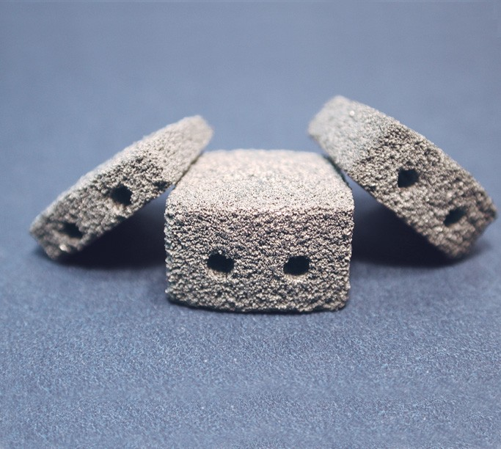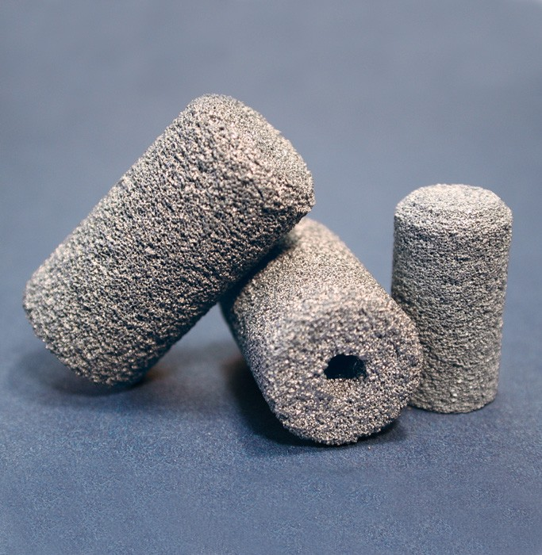
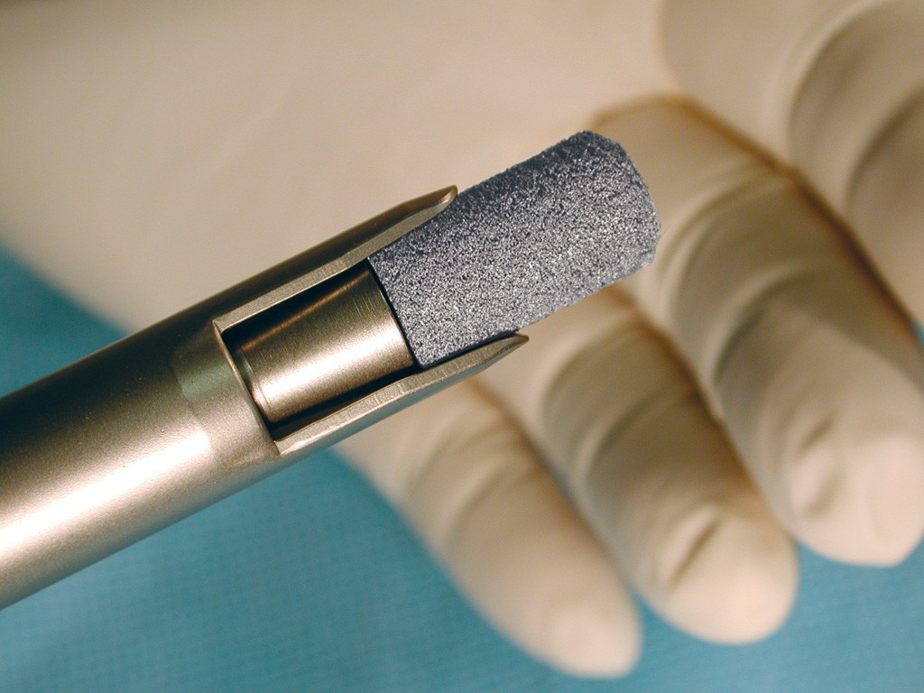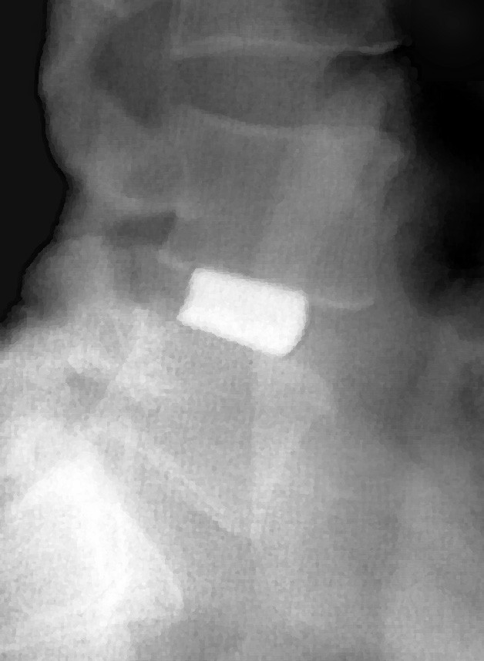
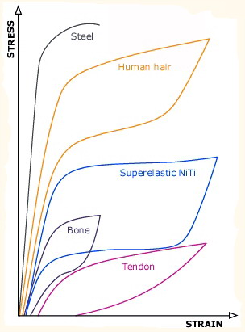
Excellent mechanical and biological properties:
Shape memory effect
Superelasticity
Biocompatibility
Biomechanical compatibility
Main applications:
Hard tissue reconstruction and replacement

2. Manufacturing process of porous TiNi SMAs
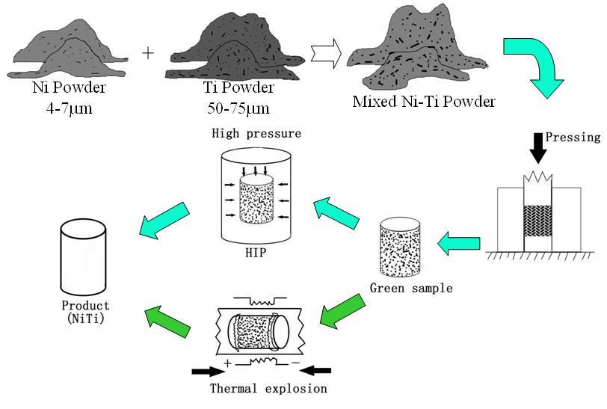

3. Pore structure of porous TiNi SMAs fabricated by CF-HIP
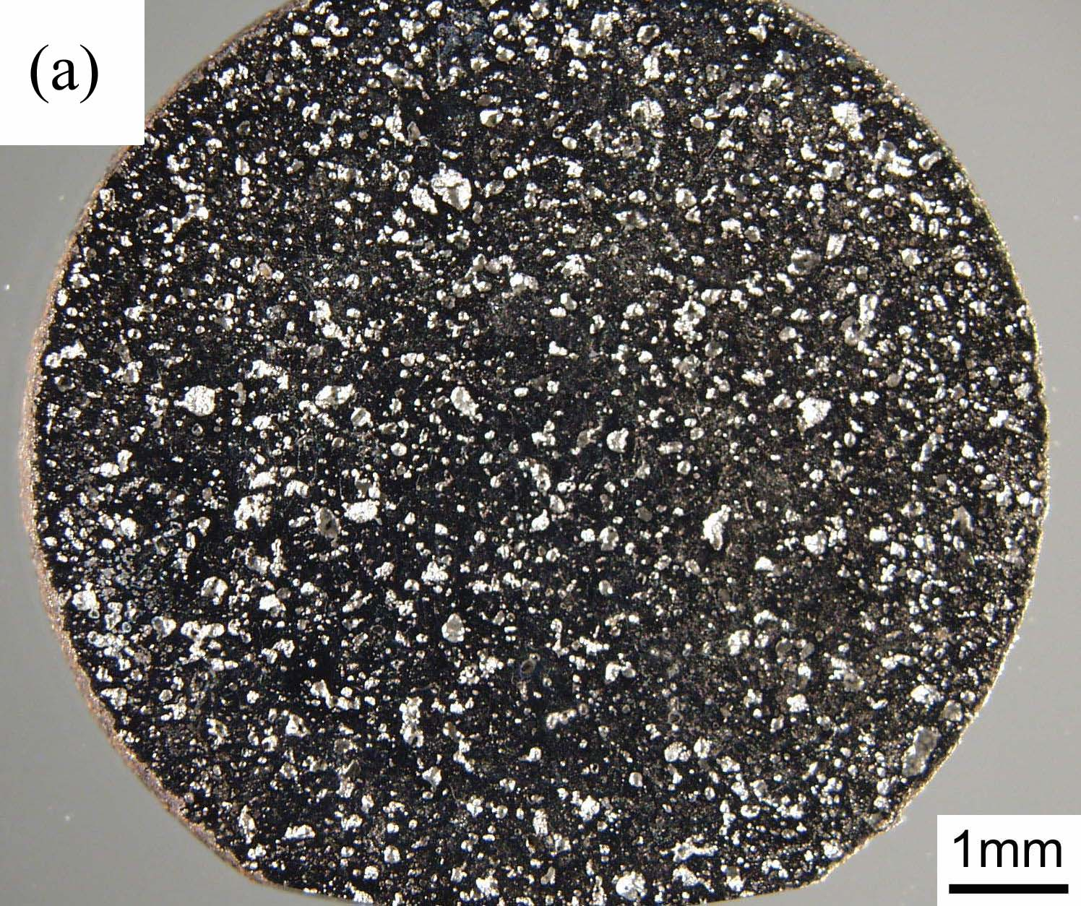

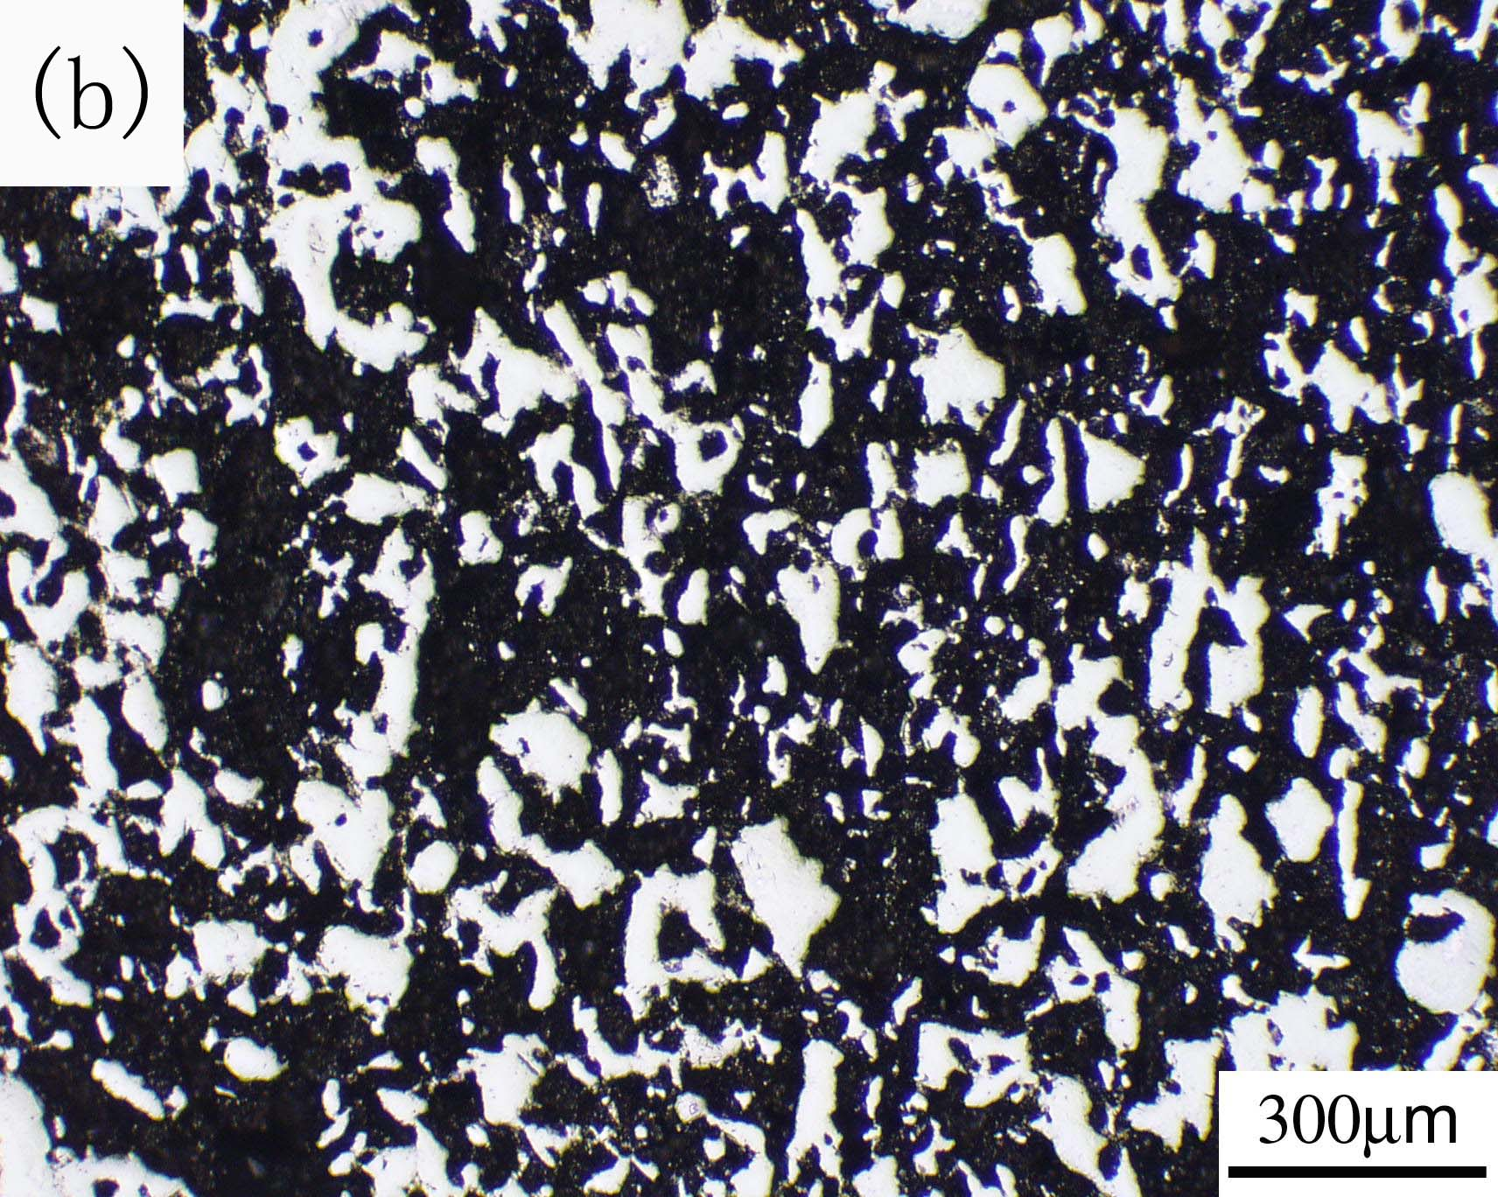
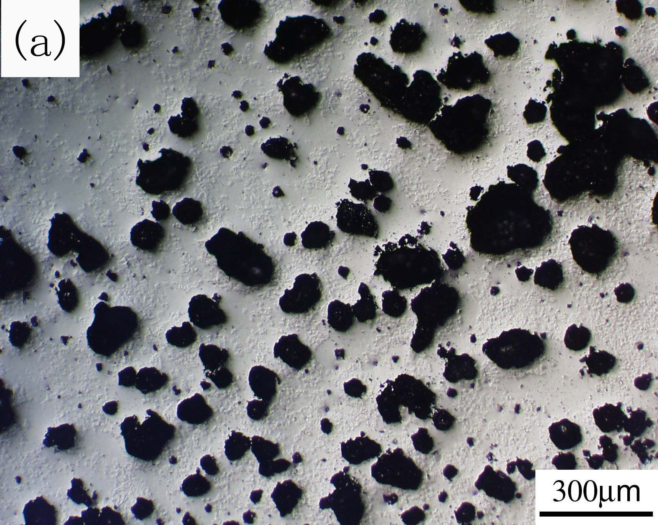

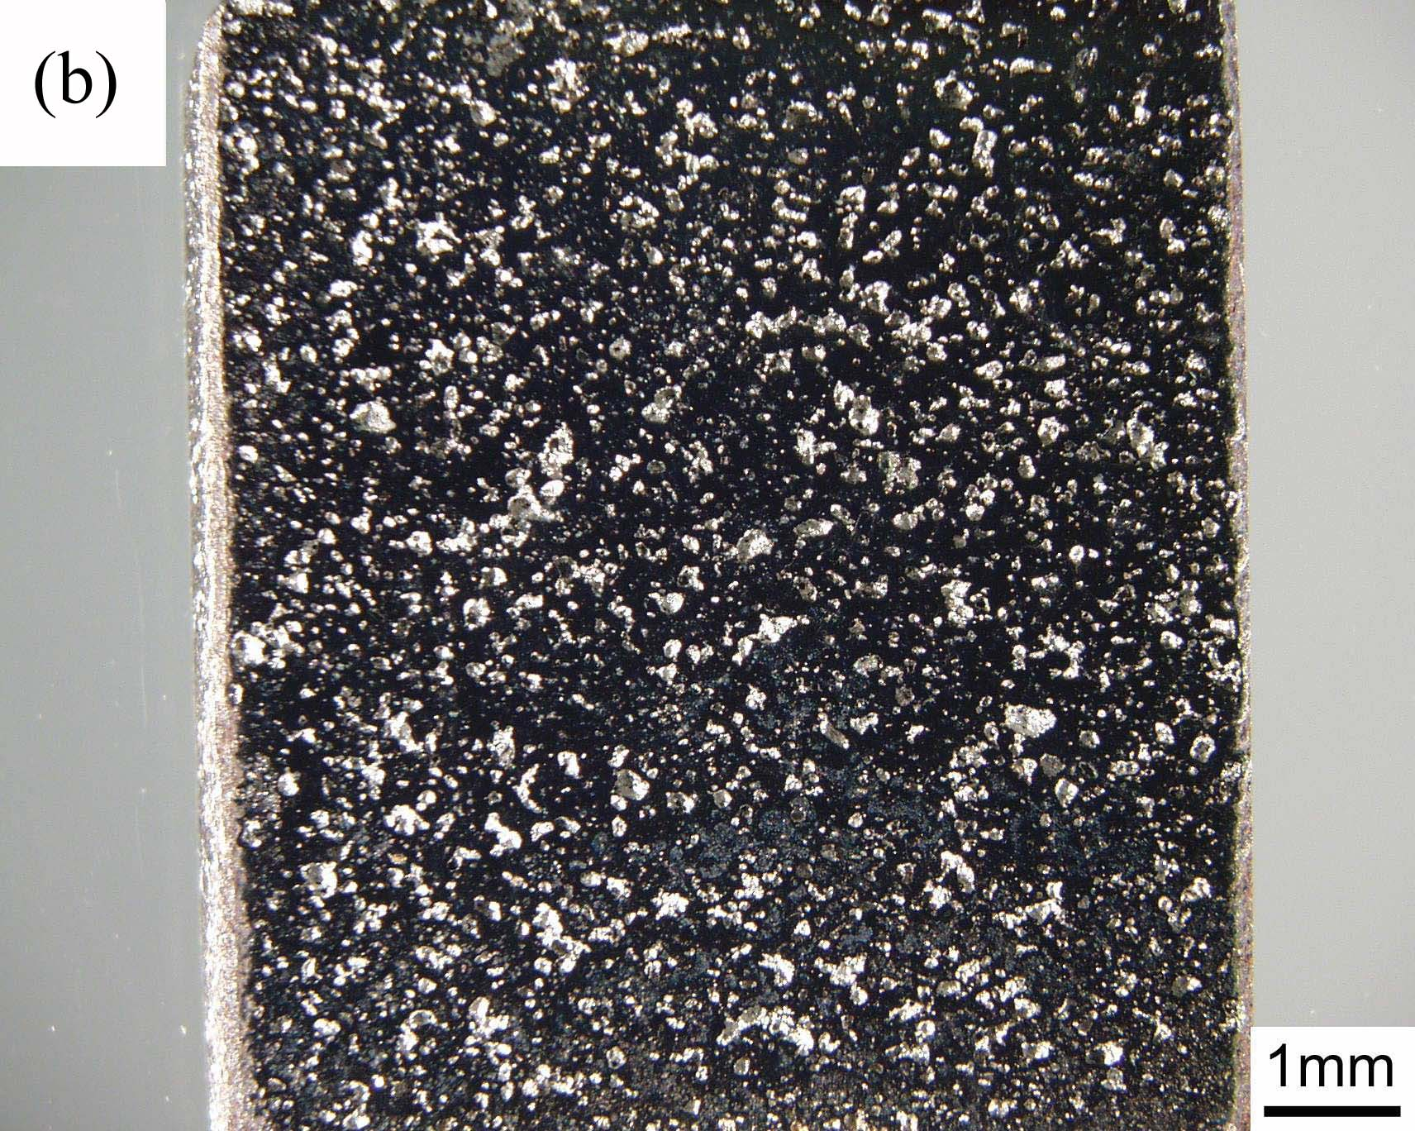
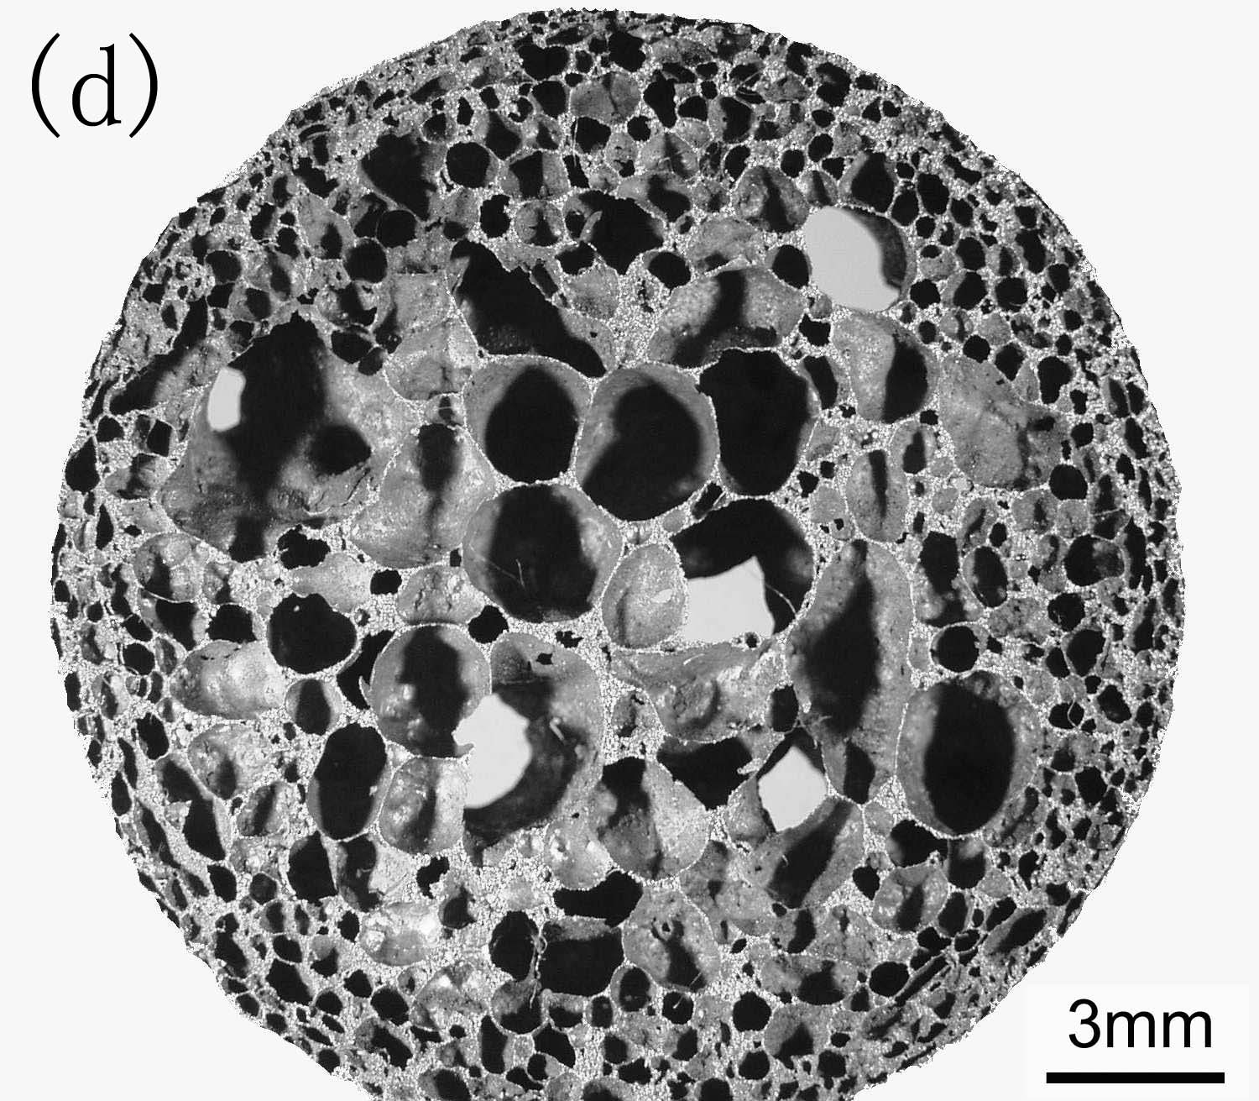
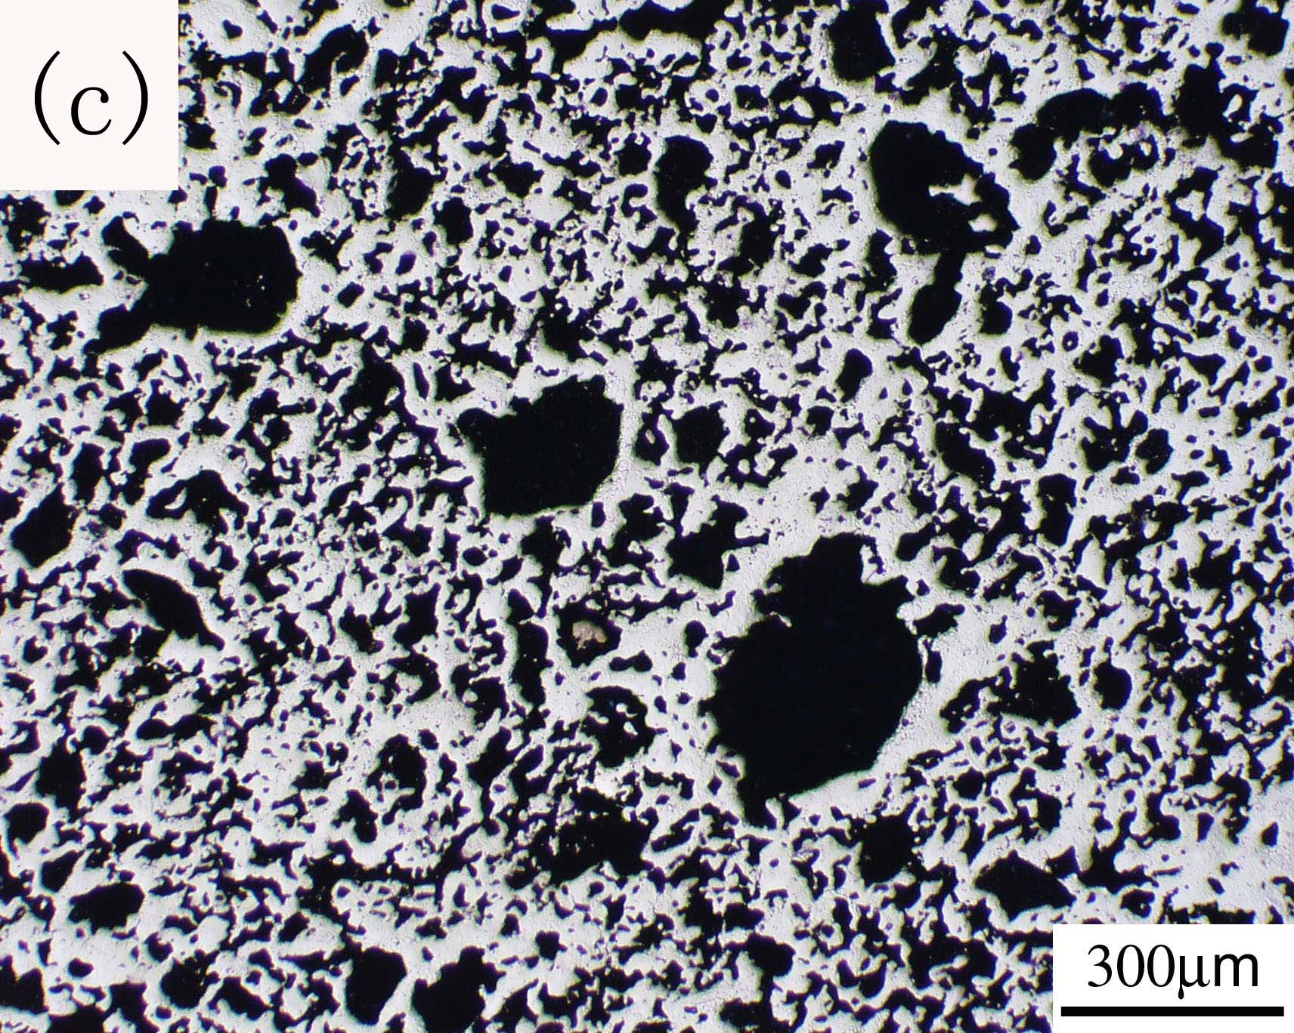

Optical macrograph of
(a) radial section; (b) axial section
Various pores microstructure of porous TiNi SMAs fabricated by CF-HIP

4. The effect of porosity on phase transformation behavior of Ni-riched porous TiNi SMAs fabricated by CF-HIP

DSC curves of porous Ti-50.8%Ni SMAs prepared by CF-HIP with different porosity: (a) Heating; and (b) Cooling

The relationship between
(a) transformation temperature; and (b) latent heats versus porosity

5. The effect of porosity on phase transformation behavior of equi-atomic porous TiNi SMAs fabricated by CF-HIP

DSC curves of Ti-50at.%Ni green samples under different cold pressure CF-HIP sintering for 3h: (a) heating; and (b) cooling. (CF-HIP parameters: 1050℃, 150MPa, and sintered for 3h, the specimens were aged at 450℃ for 0.5h, then quenched in the ice-water

6. The effect of porosity on mechanical properties and superelasticity of porous TiNi SMAs fabricated by CF-HIP

Compressive stress-strain curves of porous TiNi SMAs prepared by CF-HIP with various porosities
The effect of mechanical cycle on stress-strain curves of porous Ti-50.8at.%Ni SMAs prepared by CF-HIP.

7. The effect of fabrication method on mechanical behaviors and fracture mechanism of porous TiNi SMAs

Stress-strain curves of porous TiNi SMAs prepared by three different methods.

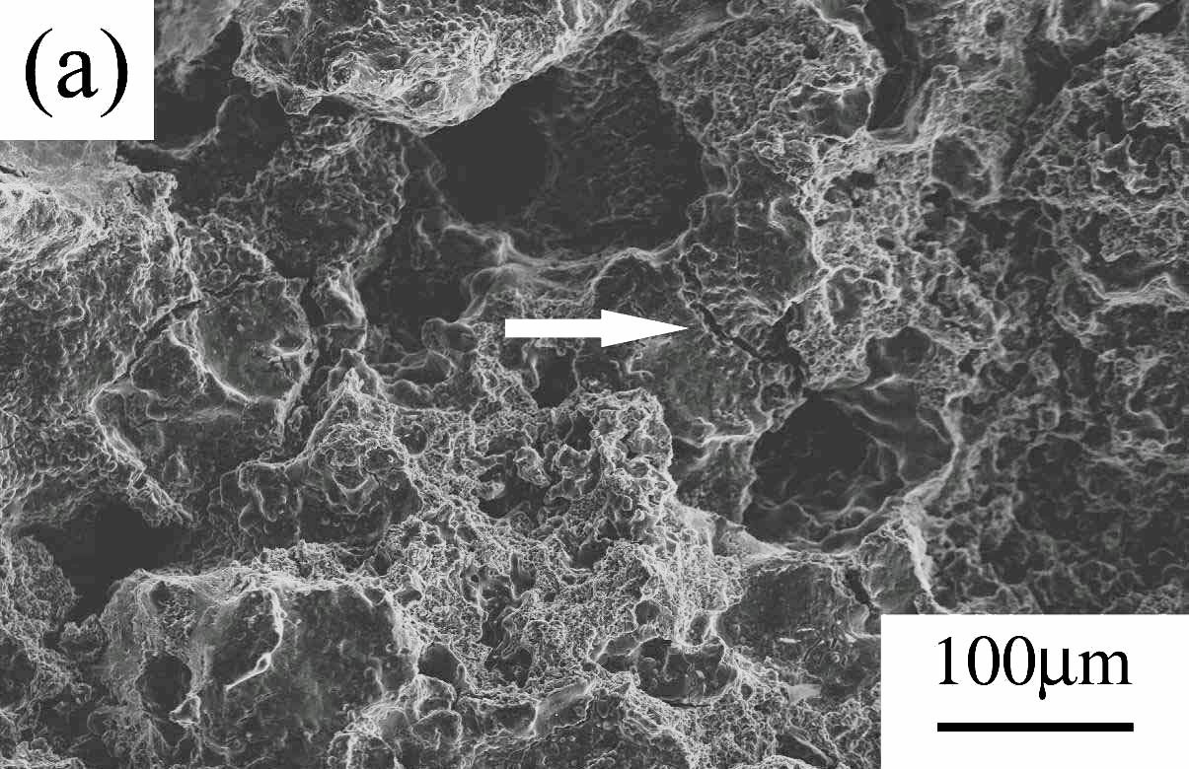
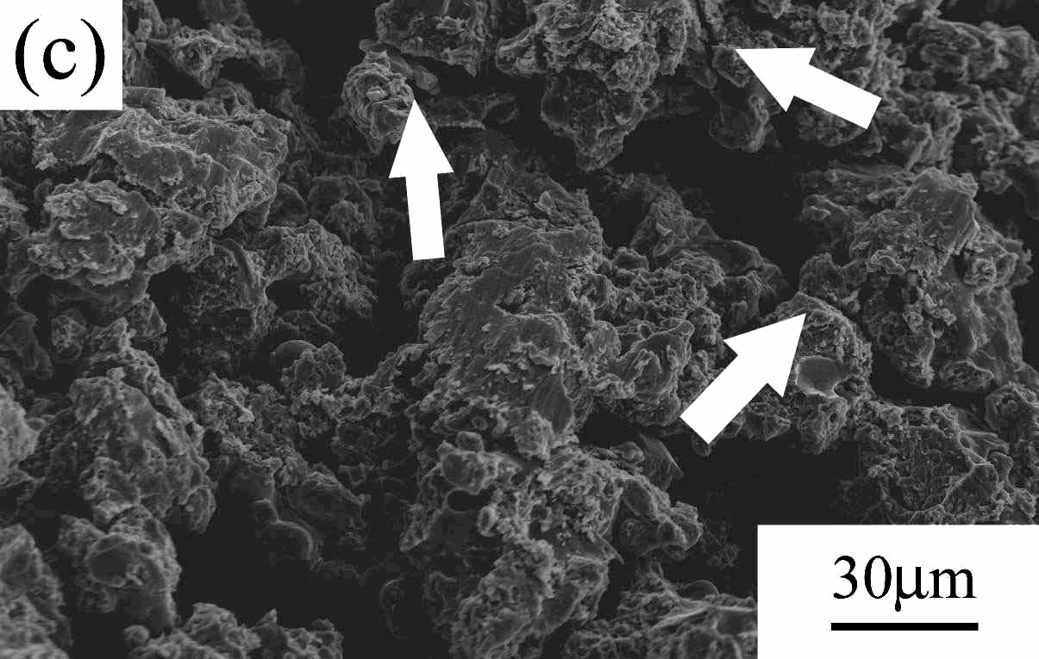
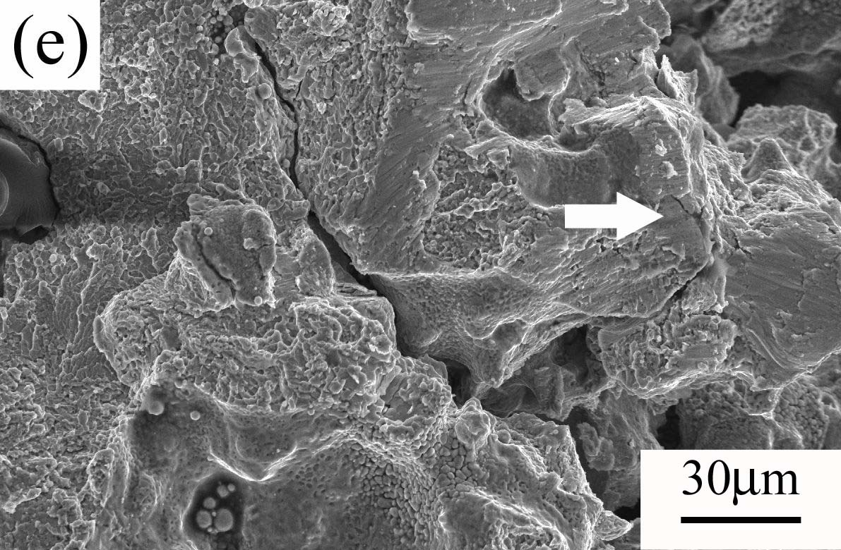

CF-HIP
CS
SHS
8. The effect of porosity on damping properties of porous TiNi SMAs
fabricated by CF-HIP

Influence of porosity ratio on IF peak temperature

Effects of porosity ratio on (a) Internal friction, and (b) elastic modulus, of porous TiNi SMAs

9. The comparison between human bone and porous TiNi SMAs
fabricated by CF-HIP

 | Bone | Porous TiNi
Biocompatibility | excellent | Excellent(predict)
Porosity, % | 30-90 | 0-78
Pore connectivity | good | good(adjustable)
Pore size, μm | 100-500  (bone tissue) | 50-3000
Pore size, μm | <100(connective fibrous tissue) | 50-3000
Elastic modulus, GPa | 2.5-22.4 | 1.7-9
Compressive yield strength, MPa | 22-210 | 36.9-467.4
Compressive strength limit, MPa |  | 110.3-336.5
