**吴贤铭智能工程学院博士研究生校长奖学金、国家奖学金申请材料**

1. **博士期间平均成绩M1**

M1=（81*2+84*3+90*3+87*1+94*2+90*2）/13=87.616

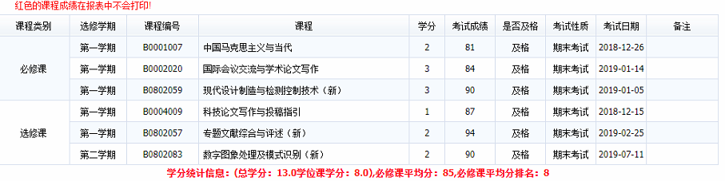

1. **学术论文加分M2**

M2=34.5

学术论文

[1]Y. Chen et al., “A Continuous Estimation Model of Upper Limb Joint Angles by Using Surface Electromyography and Deep Learning Method,” IEEE Access, vol. 7, pp. 174940–174950, 2019. Q1;(30分)

[2] S. Cai, Y. Chen, S. Huang, Y. Wu, and L. Xie, “SVM-Based Classification of sEMG Signals for Upper-Limb Self-Rehabilitation Training,” Frontiers in Neurorobotics, vol. 13, 2019. Q2;(1.5分)

[3] K. Ma, Y. Chen, X. Zhang, H. Zheng, and L. Xie, “sEMG-Based Trunk Compensation Detection in Rehabilitation Training,” Frontiers in Neuroence, vol. 13, p. 1250, 2019. Q2;(1.5分)

[4] S. Yu, Y. Chen, Q. Cai, K. Ma, and L. Xie, “A Novel Quantitative Spasticity Evaluation Method Based on Surface Electromyogram Signals and Adaptive Neuro Fuzzy Inference System,” Frontiers in Neuroence, vol. 14, 2020. Q2;(1.5分)

**总评估量化公式**

M=M1*80%+M2+M3+M4=104.59