**吴贤铭智能工程学院博士研究生校长奖学金、国家奖学金申请材料**

**1.博士期间平均成绩M1**

M1=(83*2+94*3+95*3+95*2+94*2)/12=92.5833

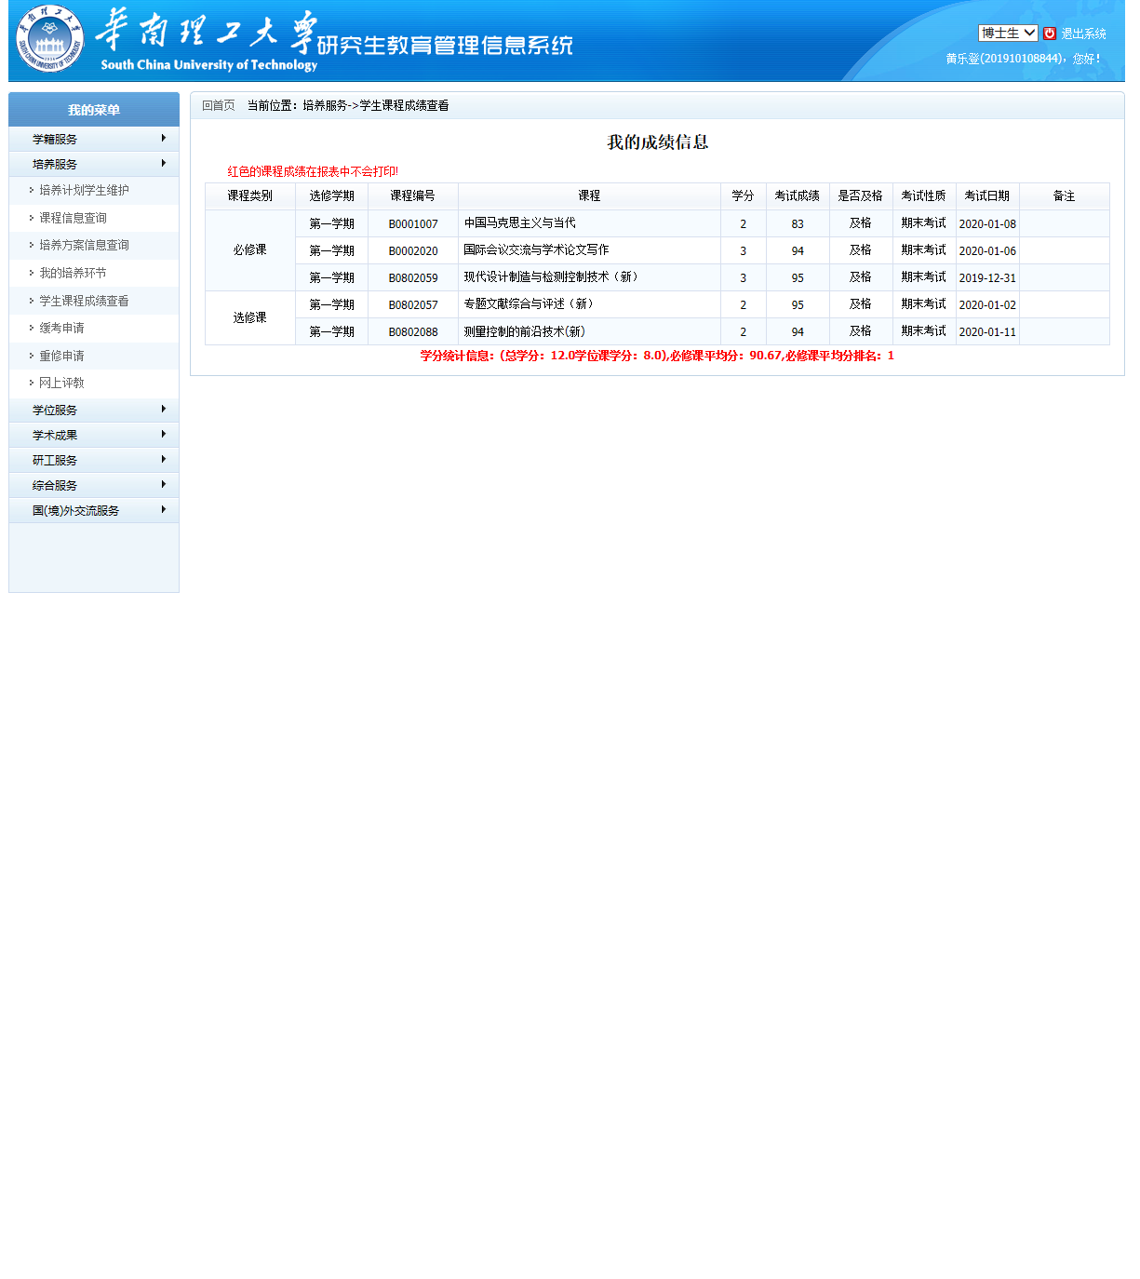

**2.科研成果加分M2**

M2=46.5分

学术论文

1. **Huang L**, Yang Z, Wang R, et al. Physiological and biomechanical effects on the human musculoskeletal system while carrying a suspended-load backpack[J]. Journal of Biomechanics, 2020: 109894. SCI Q3; (20分)

2. **Huang L**, Wang R, Yang Z, et al. Energy Harvesting Backpacks for Human Load Carriage: Modelling and Performance Evaluation[J]. Electronics, 2020, 9(7): 1061. SCI Q2；（25分）

3. Xie L, Huang G, **Huang L**, et al. An unpowered flexible lower limb exoskeleton: Walking assisting and energy harvesting[J]. IEEE/ASME Transactions on Mechatronics, 2019, 24(5): 2236-2247. SCI Q1; (1.5分)

**总评定量化公式：**

M = M1*80% + M2 + M3 + M4=92.5833*80%+46.5=120.5664分