**吴贤铭智能工程学院博士研究生校长奖学金、国家奖学金申请材料**

1. **博士期间平均成绩M1**

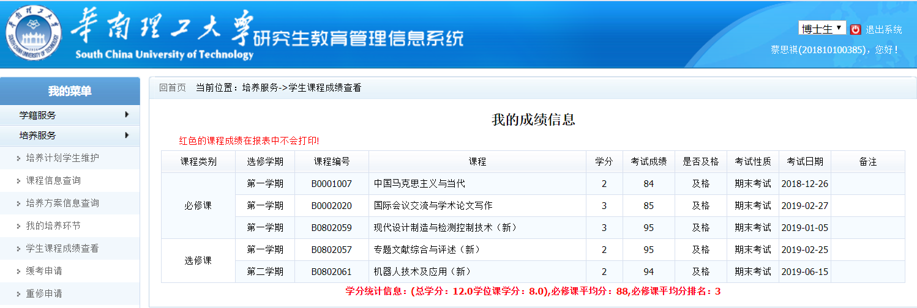

**M1=( 2*84+3*85+3*95+2*95+2*94)/12=90.5分**

**2. 科研成果加分M2**

(1)**学术论文**

1. Cai Siqi, Xuyang Wei, Enze Su, Weifeng Wu, et al.. Online compensation detecting for real-time reduction of compensatory motions during reaching: a pilot study with stroke survivors[J]. Journal of NeuroEngineering and Rehabilitation, 2020, 17(1): 1-11. (SCI一区，本人为第一作者)；（30分）
2. Cai Siqi, Guofeng Li, Enze Su, et al. Real-time detection of compensatory patterns in patients with stroke to reduce compensation during robotic rehabilitation therapy[J]. IEEE Journal of Biomedical and Health Informatics, 2020. (SCI一区，本人为第一作者)；（30分）
3. Cai Siqi, Guofeng Li, Longhan Xie*, et al. Detecting compensatory movements of stroke survivors using pressure distribution data and machine learning algorithms, Journal of Neuroengineering and rehabilitation, 2019, 16(1): 1-11. (SCI一区，本人为第一作者)；（30分）
4. Xie Longhan*, Cai Siqi, et al. On Energy Harvesting from a Vehicle Damper, IEEE/ASME Transactions on Mechatronics, 2019. (SCI一区，导师一作，本人二作) （30分）
5. Song Yonghao, Cai Siqi, Yang Lie and Xie, Longhan*. A Practical EEG- based Human-Machine Interface to Online Control an Upper-Limb Assist Robot[J]. Frontiers in Neurorobotics, 2020, 14: 32. (SCI二区，本人为第二作者)；（1.5分）
6. Cai Siqi, Weifeng. Wu and Longhan. Xie, "Dual-Arm Upper Limb Rehabilitation Robot: Mechanism Design and Preliminary Experiments," 2020 6th International Conference on Control, Automation and Robotics (ICCAR), Singapore, Singapore, 2020, pp. 80-86, doi: 10.1109/ICCAR49639.2020.9108019. (EI收录，学生本人出国参加学术会议），（1.5+1.5分）。

(2)**专利（导师为第一作者、本人为第二作者）**

1. 已授权实用新型专利：一种交互式上肢康复训练系统（4分）

授权日：2020-06-19

1. PCT国际专利：一种交互式上肢康复训练系统PCT/CN2018/124825（1分）
2. PCT国际专利：一种多模态交互的上肢康复机器人训练系统，PCT/CN2019/114915（1分）

M2=124.5 + 6=130.5分

**4. 其他活动加分M4**

获得十大学生共产党员 2分

获得优秀志愿者（校级） 1分

M4= 3分

**总评定量化公式为：**

M = M1*80% + M2 + M3 + M4 = 205.9分