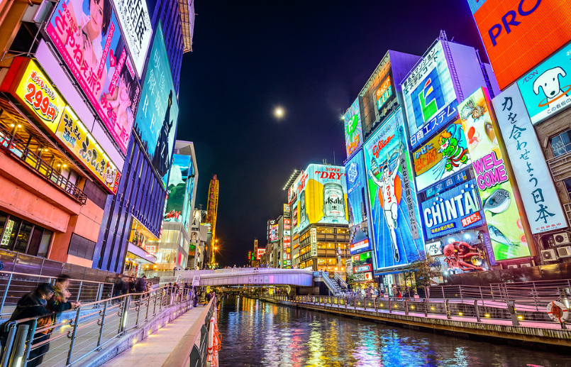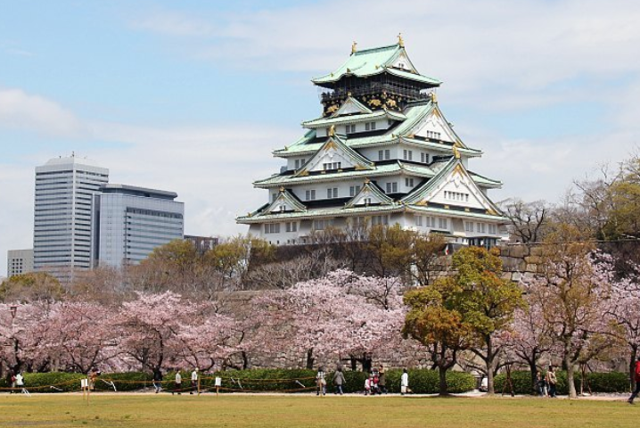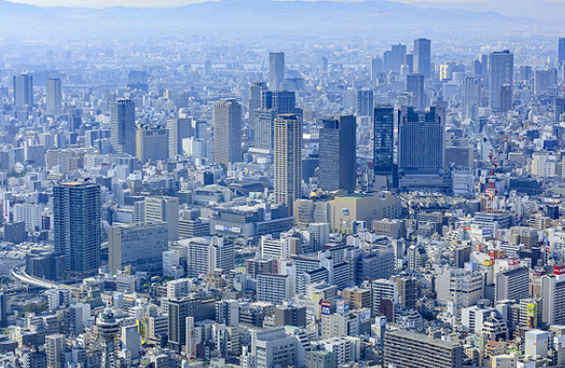

**大学生国际创业大赛2019AW in 大阪**

**（第4届 2019年11月24日-28日于日本大阪）**

**International Entrepreneurship Contest for University Students 2019AW in Osaka**

**(November 24th-28th,2019,Osaka,Japan）**

大学生国际创业大赛执行委员会

Executive committee of International Entrepreneurship Contest for University Students

2019年8月29日

August 29, 2019

1. **大赛目的与任务Objectives And Tasks of The Competiton**

大学生国际创业大赛是由大学生国际创业大赛执行委员会发起的多国籍在校高校学生参加的创新创业大赛。本次大赛将于2019年11月24-28日在日本大阪市举办。截止目前，大学生国际创业大赛已经成功创办三届（2018年5月，2018年11月，2019年5月），并得到了来自日本社会各界的支持。我们邀请来自不同国家的大学生创新创业团队参加本届大赛，并将在大阪现场决赛选出最优秀奖。我们相信创新创业的理念对各国年轻人的未来成长都是至关重要的。本次大赛不仅为参加者提供创新创业优秀项目的展示平台，也能为他们提供强有力的支撑，乃至提供被投资机会和寻求当地和世界各地优秀合作伙伴的机会。截止目前，通过大赛组委会已有多所高校的参赛队伍获得创投资金或正与投资人洽淡之中。

The International Entrepreneurship Contest is a business plan competition for multinational univeristy students. It will be held from November 24th to 28th, 2019. The best entrepreneur teams are invited to compete in Osaka, where the champion of the contest will be decided. We believe that the spirit of innovation is vital to the development of young minds. This contest will not only provide a platform for cutting-edge business ideas, but also brings great investment opportunities with the support of excellent business partners.

1. **组织机构Institutional Framework**

**主办单位 Host**

大学生国际创业大赛执行委员会

Executive committee of International Entrepreneurship Contest for University Students

**合办单位 Co-organizers**

大阪市，大阪大学联盟，京都大学联盟，兵库神户大学联盟，中小企业基盘整备机构近畿本部，京都大学Original株式会社。

Osaka, The Consortium of Universities in Osaka , The Consortium of Universities in Kyoto

The Consortium of Universities in Hyogo, Kobe

Organization for Small & Medium Enterprises and Regional Innovation, Kinki Japan

Kyoto University Original Co., Ltd

**协办单位 Supporters**

大阪府，日本国经济产业省近畿经济产业局，关西经济联合会，早稻田-EDGE人才培养项目

Osaka Prefecture，Kansai Bureau of Economy, Trade and Industry（METI Kansai）

Kansai Economic Federation，WASEDA-EDGE Global Talent Development Program

**承办单位 Organizer**

株式会社GES

生田GLOBAL株式会社

Global Education Service Co., Ltd

IKUTA Global Co., Ltd.

1. 大赛专家委员会 The Main Judge Commissions**（暂定）**

|  |  |  |
| --- | --- | --- |
| 姓名 | 职务 | 所属 |
| 西本 清一 | 总评委 | 公益财团法人京都高度技术研究所 理事长 |
| 原 良宪 | 评委 | 京都大学 经营管理学研究生院（MBA） 院长 |
| 岛冈 未来子 | 评委 | 早稻田大学 政治经济学术院 教授  WASEDA-EDGE 人才培养项目事务局 代理局长 |
| 菅原 智 | 评委 | 关西学院大学 商学院 教授 |
| 金 昌柱 | 评委 | 立命馆大学 经营学院 教授 |
| 吉野 庆一 | 评委 | Dari K株式会社 CEO |
| 牧野 成将 | 评委 | 株式会社Darma Tech Labs CEO |

**专家介绍：**

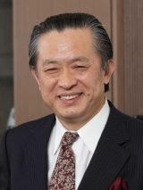

**西本 清一 公益财团法人京都高度技术研究所 理事长**

京都大学工学博士，曾任日本京都大学工学研究生院院长，现任京都高度技术研究所理事长。其不仅有较强专业知识与学术成就，对于日本的产业发展也有很深的理解。

**Seiichi Nishimoto,** **Chairman of Local Independent Administrative Agency Kyoto Municipal Institute of Industrial Technology and Culture Professor Emeritus, Kyoto University.**

From a college student to a respectful professor, he focused his entire academic career at one university – Kyoto University. In the true spirt of liberty, he continues to contribute to the development of industrial technology after his retirement from Kyoto University.

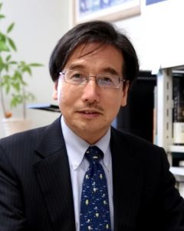

**原 良宪 京都大学 经营管理学研究生院（MBA） 院长**

京都大学情报学博士，斯坦福大学访问学者，NEC北美研究所（硅谷研究部部长），现任京都大学经营管理学研究生院（MBA） 院长。原 良宪教授同时也担任日本多所研究机构与组织的委员职务。

**Yoshinori Hara, president of Graduate School Of Management, Kyoto University.**

Received a B.E. and M.E. from the University of Tokyo and Ph.D. (Informatics) from Kyoto University. Dr. Yoshinori Hara has been a professor in the Kyoto University Graduate School of Management since April 2006, when the graduate school was first established. His current research focuses on innovation management, service and design management, and open innovation with IT frameworks.

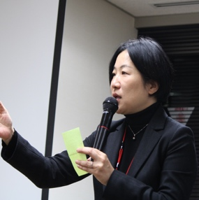

**岛冈 未来子 早稻田大学 政治经济学术院 教授**

**WASEDA-EDGE 人才培养项目事务局 代理局长**

早稻田大学公共经营学博士毕业，2011年起担任地球环境战略研究机关特任研究员，并兼任早稻田大学商学学术院研究中心助手研究员。2014年担任早稻田大学研究战略中心讲师，2016年起担任研究战略中心教授，并兼任WASEDA-EDGE 人才培养项目事务局代理局长。

**Mikiko Shimaoka, Waseda University Deputy General Manager, WASEDA-EDGE program.**

 Ph.D. in Public Management, Waseda University, Advisor for the "Accelerate Cooperative Efforts to Promote Regional Vitalization", Deputy General Manager of WASEDA-EDGE program, and professor in Waseda University.

Specialized fields: Management of Nonprofit Organizations, Stakeholder Management, Collaborative Governance.

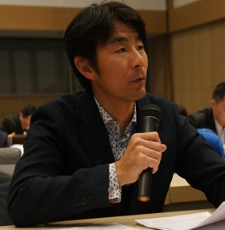

**菅原 智 关西学院大学 商学院 教授**

横滨国立大学国际开发经营学博士，同时获得了悉尼大学教育社会学博士。主攻会计学，对于会计学教育与培训的相关的领域也有着深入的研究。

**Satoshi Sugahara, professor of Economics, Kansai Gakuin University.**

Ph.D. in Division of International Business Law, Yokohama University; Master in Business Administration and Information Management, Australian National University. He is the member of International Association for Accounting Education and Research, and also a member of American Accounting Association.

Specialized fields: Business Administration, Accounting.

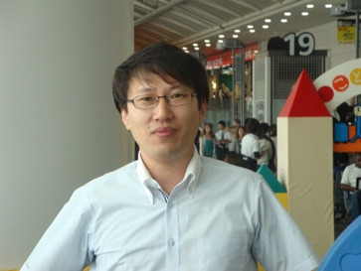

**金 昌柱 立命馆大学 经营学院 教授**

大阪市立大学经营学博士，主攻市场营销，零售业企业战略。现任日本商业学会国际企划委员长，韩国物流学会副会长等多家学术机构重要职务。同时兼任日本知名咨询企业IZUMIYA综合研究所研究员。

**Changju KIM, professor of College of Business Administration, Ritsumeikan University.**

Master in Strategic Marketing, Cardiff University (the United Kingdom), Ph.D. in Commerce, Osaka City University. He is a member of the Japan Society of Marketing and Distribution. His research topic is strategic issues on the merchandising innovation in retail company.

Subjects of research: Merchandising Innovation in Retailing, Innovative Sales Management and Firm Performance, and Firm Growth and Value Innovator.

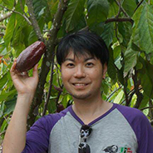

**吉野 庆一 Dari K株式会社 CEO**

毕业于日本京都大学，后留学于英国牛津大学并取得硕士学位。曾任职于外资投资公司摩根士丹利，担任金融分析师。吉野社长于2011年辞职创立了Dari K株式会社，并担任CEO。

**Keiti Yoshino, CEO of Dari.K**

After graduating from the Graduate School of Kyoto University and the Graduate School at Oxford University, Keiichi Yoshino worked as a financial analyst in the banking and investment sector.  He is currently the CEO of Dari K., a cacao bean importing company that successfully improved the quality and productivity of cacao beans on the Sulawesi Island of Indonesia, which is now the second largest producer in the world.

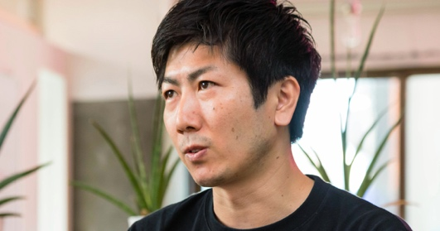

**牧野 成将 株式会社Darma Tech Labs CEO**

神户大学硕士毕业，曾先后任职于Future Venture Capital ，京都高度技术研究所，SunBridge Global Ventures，The Founder Institute，后创立株式会社Darma Tech Labs，担任公司CEO。牧野社长多年来主要从事于创新型初创企业的投资与咨询工作。

**Narimasa Makino, CEO of Darma Tech Labs.**

M.B.A from Kobe University. Before building his dream high tech company, he invested much of his time helping entrepreneurs and working with startups through organizations including the Future Venture Capital, SunBridge Global Ventures, and The Founder Institute. He is currently a co-founder and CEO of Darma Tech Labs, which runs a prototyping acceleration program for hardware startups.

1. **参赛项目要求Entry Requirements**

参赛项目要求能够将互联网，新能源，生物医药，文化传承等信息技术与文化生活紧密结合。

Entries need to be able to closely integrate information technologies such as internet, new energy, biomedicine, and cultural heritage with cultural life.

参赛项目主要包括以下类型：The entries mainly include the following types：

1. 通讯，IT，科技Telecommunication, IT, Technology
2. 环境改善，新能源Environmental Improvement, New Energy
3. 卫生健康，生物医药Health, Biomedicine
4. 传统文化，文化创意Traditional culture, cultural creativity

行业与形式不限，前提为需要遵守当地法律习俗习惯。

Industry and form are not limited, provided that it is necessary to abide by local laws and customs.



1. **参赛对象Participants（Sign-up as a team）**

参赛项目具有较好的创意和较为成型的产品原型或服务模式。

The projects shall be creative and present relatively mature product prototypes or service modes.

以团队为单位报名参赛。参赛团队需为高等院校全日制在校学生（可为本专科生，研究生，专科生。不含在职生）。每个团队不少于4人，上限8人。

Team participation. Teams need to be students in colleges or universities (Can be a college student, graduate student. Excluding working students.) Each team has no less than 4 people and a cap of 8 people.

※参赛费用自行负责。

we are not responsible for your entry fees.

大赛不仅帮助参赛团队对接投资机构，还将发放实质奖金。

The contest not only helps the participating teams to connect with the investment institutions, but also grants real bonuses

**参赛语言：**

英語（发表使用语言）。

Language of contest : English (Presented in English.)

1. **比赛赛制Rules**

大赛采用报名资料筛选初赛，日本复赛，总决赛三级赛制。初赛由主办方对提交资料进行审核，通过者将被邀请到日本参加复赛。

初赛-参赛资格审核及商业计划审核（国内进行）

复赛-11月26日（日本大阪）

决赛-11月27日（日本大阪）

The contest uses the registration data to select the preliminary game, the Japanese semi-finals and the finals are three-tiered. In the preliminary round, the passers will be invited to Japan to participate in the semi-finals after the reviewing of the submitted materials by organizers.

 

1. **赛程安排Schedule**

参赛报名截止日期：2019年10月20日

Registration Deadline: October 20, 2019

对于提交的商业计划书进行筛选后，邀请参加复赛团体。

After screening the submitted business plan, we will invite qualified teams to participate in the rematch group.

【初赛结果发表】2019年10月23日邮件通知

[Preliminary Results Announcement] Email notification on October 23, 2019

总日程5天。2019年11月24日-28日

The total schedule is 5 days. November 24-28 2019

详细日程： Schedule Detail

|  |  |  |  |
| --- | --- | --- | --- |
| 时间Time | 事项Scheduled Event | 备注Notes | 会场Location |
| 11月24 （Day1）  November 24 | 抵达日本  Arrival of students from overseas | 欢迎晚宴  Welcome party in the evening | 大阪  Osaka |
| 11月25 （Day2）  November 25 | 大赛说明会&演讲会  Contest orientation and seminar | 日本企业家演讲  专家指导  Speech and seminars from professional entrepreneurs | 大阪大学  Osaka University |
| 11月26 （Day3）  November 26 | 分组预赛  Preliminary Contest |  | 大阪  Osaka |
| 11月27 （Day4）  November 27 | 决赛，颁奖晚会  Final contest & awards ceremony |  | 大阪市创新中心  Osaka Innovation HUB |
| 11月28 （Day5）  November 28 | Am大阪产业文化参观  Tour of industries and culture of Osaka  pm回国  Departure of students from overseas |  | 大阪  Osaka |

1. **审查规则Review Rules**

|  |  |
| --- | --- |
| **评审要点**Criteria | **评审内容**  Details |
| 创新性  Innovation | 所提供的商品或服务的优势，竞争力，技术性能等，以及对解决社会问题或客户需求所能提供的价值，商业模式的特点等。  The advantages, competitiveness, technical performance of the products or services provided, the value to solve social problems or to satisfy customer needs, and the characteristics of the business model, etc. |
| 市场分析  Market analysis | 消费群体分析。所提供的产品或服务能够为消费者提供什么样的价值或满足消费者什么样的需求。  行业现状分析。该产品所处的市场行业现状以及对未来的预测分析。如有需要可以附上具体的数据与相关分析。  Consumer group analysis. What kind of value can the product or service provide to the consumer or what kind of demand can satisfy the consumer. Industry status analysis. The market status of the product and the forecast analysis. Please attach specific data and correlation analysis if necessary |
| 具体运营  Specific operation | 如何具体展开运营，包括推广，营销，管理，战略等，以及在推广展开过程中会遇到的难点。  How to conduct operation, including promotion, marketing, management, strategy, etc., and the difficulties encountered in the process of promotion and expansion. |
| 财务管理  Financial management | 从创业初期开始到三年之内的具体财务计划以及该计划的可行性。  A specific financial plan from the start up to three years and the feasibility of the plan. |

1. **报名方式Registration method**

在指定表格（附件：参赛资料）里用英语填写后，转换为PDF格式(文件小于3M)，并将PDF文件发送到邮箱：[info@kyoto.academy](mailto:info@kyoto.academy)

Completed the specified form in English (Annex: Entries), convert it to PDF format (file less than 3M), and sent PDF file to email: [info@kyoto.academy](mailto:info@kyoto.academy)

※注意事项：Precautions:

・【表格】：10页以内。参考资料：5页以内

[Form]: Less than 10 pages. References within 5 pages

邮件名为「【IECO2019】大学名」，附件名为「【IECO2019】大学名_商业计划题目的前五个字母」

The email shall be named "[IECO2019] University Name", and the attached name is "[IECO2019] University Name_ Title of Business Plan "

1. **大赛奖励Awards**

一等奖　1个 奖金30万日元 Gold Prize 1 . Bonus 300,000 yen

二等奖 2个 奖金20万日元 Silver Prize 2 . Bonus 200,000 yen

三等奖 3个 奖金10万日元 Bronze 3 . Bonus 100,000 yen

获奖项目颁发获奖证书。优秀商业计划有机会获得天使投资。（2018年创业大赛结束后，有日本参赛团队成功获得一亿日圆投资。）

The award-winning projects get the award certificate. Excellent business plan has the opportunity to get angel investment.

1. **项目费用Expenses**

参加费用：8,800元

Participation fee:￥8800 RMB

费用包括：报名费，大赛期间住宿费，交通费。邀请函国际邮递费，欢迎宴会・结业会餐费，海外医疗保险费。

The expenses cover: Expenses of registration, Accommodation & transportation during the contest, International postage of invitation letters ,Banquet twice (welcome party and farewell party ),Overseas medical insurance.

不包括的费用：国际机票费，个人护照办理费，签证手续费，国内交通费，餐费，行李超重费，个人购物消费，接送机费，其它“费用包括”以外的费用。

The expenses DO NOT cover: International Airline tickets, Passport application, Visa service, Transportation outside Japan, Meals, cost of baggage overweight, Personal shopping, And other expenses that are NOT included in the 'covered items' mentioned above.

**注意事项Precautions**

※所提出的商业计划的知识产权归提出该商业计划的团队所有。

The intellectual property of the proposed business plan belongs to the team that proposed the business plan.

※入选者的商业计划简要会在网络进行公开，所以为保护个人知识产权，必要的情况下可以事前进行正式专利申请。另外，所做商业计划为技术或是商品的情况下，请提前确认市面上是否有同类商品或技术存在。

The business plan of the selected candidate will be disclosed on the Internet in brief. Therefore, in order to protect personal intellectual property, a formal patent application can be made in advance if necessary. In addition, if the business plan is technical or commodity, please confirm whether there is any similar product or technology in the market in advance.

※关于本次大赛参赛各队的商业计划内容主办方有权在媒体上进行刊登。

Organizers have the right to publish the content of the business plans for each team participating in the competition in the media

※提交过后的商业计划书及其相关资料不退还，请提前准备好备份。

The submitted business plan and related materials will not be returned. Please prepare your backup in advance.

不可侵害他人的知识产权，因侵害他人知识产权所产生的一切后果，由相关个人或团队负全部责任。如果发生获奖队伍的商业计划侵害到了他人的知识产权的情况，大赛委员会有权取消该参赛队伍所获得的奖项。

It is not allowed to infringe other people’s intellectual property rights. All the consequences arising from infringement of the intellectual property rights of others shall be the sole responsibility of the relevant individual or team.

**International Entrepreneurship Contest for University Students 2019AW in Osaka**

|  |  |  |  |
| --- | --- | --- | --- |
| Title of Business Plan |  | | |
| Business Plan Summary |  | | |
| Academic Institution |  | | |
| Team Leader | Name |  | |
| Academic Institution |  | |
| Major |  | |
| Grade |  | |
| E-mail |  | |
| Telephone |  | |
| Team Members | Name | Academic Institution or Major | Grade |
|  |  |  |
|  |  |  |
|  |  |  |
|  |  |  |
|  |  |  |
|  |  |  |
|  |  |  |

|  |  |
| --- | --- |
| 1 Innovation  Characteristics of the product or service outlined by the business plan (such as its unique strengths, competitiveness, contribution to social issues, and technical performance) will be evaluated. | |
|  | |
| 2. Market Analysis  Market research such as key aspects of the core target customers, how the product/service will fulfill the needs of the target group(s), and growth prospects should be considered. | |
|  | |
| 3. Business Operation  Explain how the business plan will be implemented for the company to reach its goals. Include information such as promotion and marketing strategies, and management of foreseeable challenges. |
|  |
| 4. Financial Management  Illustrate the feasibility of the business via the company profit model/financial plans, and projections for the first three years of operation. |
|  |

**中国大陆地区参赛成员信息表**

|  |  |  |  |  |
| --- | --- | --- | --- | --- |
| **姓名** | **性别** | **生日** | **护照号** | **联系方式（微信/QQ/手机）** |
|  |  |  |  |  |
|  |  |  |  |  |
|  |  |  |  |  |
|  |  |  |  |  |
|  |  |  |  |  |
|  |  |  |  |  |
|  |  |  |  |  |

＊中国大陆地区参赛者在提交报名表格时需要将「**中国大陆地区参赛成员信息表**」一同提交。如果没有护照，则在护照号一栏填写「暂无」。