Dear Partners,

Nomination and Application for Student Exchange Programmes, Summer Term 2018

Summer Term 2018
Our Summer Term 2018 consists of 3 sessions:
 | Study Period | Application Deadline
Session 1 | 30 May – 9 July 2018 | 2 March 2018
Session 2 | 3 July – 20 July 2018 | 6 April 2018
Session 3 | 23 July – 10 Augusts 2018 | 20 April 2018*
*The application deadline for Session 3 is now extended to 20 April 2018.

Similar to the previous years, we will continue to offer the 2 to 1 Summer Exchange Programme for all existing partners regardless of the number of sessions the students enroll, i.e. 2 students participating in our summer term is equivalent to 1 student coming for our regular exchange in Fall/Spring. Tuition fee is waived as normal practice. Accommodation fee will depend on the terms and conditions of the exchange agreement between Lingnan and your institution. In general, hostel fees are approximately HK$2,150* for Session 1 and HK$1,250* for Session 2 or 3 for the whole summer term, including electricity and air-conditioning.

*Note. The amounts are under the University’s review and are subject to change.

Courses on Offer and Class Schedule
Credit-bearing/ Non-credit-bearing Courses: http://www.ln.edu.hk/summer/courses/index.php
Open Courses: http://www.ln.edu.hk/summer/courses/opencourses.php

 | Choice of Courses
Session 1 | A maximum of 2 Credit-bearing/ Non-credit-bearing courses
Session 2 | 1 Credit-bearing/ Non-credit-bearing course only
Session 3 | 1 Credit-bearing/ Non-credit-bearing course only

Exchange students can take a maximum of TWO Credit-bearing/ Non-credit-bearing Courses throughout Sessions 1, 2 and 3. Students are also welcome to take Open Courses if the class schedules do not clash with the selected Credit-bearing/ Non-credit-bearing Course(s). Students could take courses from Session 2 and 3 jointly but are not allowed to take Credit-bearing/ Non-credit-bearing Courses from both Sessions 1 and 2 due to the overlapping of class schedule. Students are advised to consult their academic advisors at home institution regarding their course selection at Lingnan University and double check for the class schedule before submitting their initial course plans.

Eligibility
All nominated students have to fulfill the following academic requirements for our exchange programme:
- Have completed at least 2 terms of full-time study but not in the final-year-final-semester at home institution
- A cumulative Grade Point Average of 2.5 (on a 4-point scale) or above
- For non-English native speaker, a TOEFL score of 213 (computer-based), 550 (paper-based) or 79 (internet-based), or an IELTS (Academic Module) score of 6.0 is required. We also accept a TOEIC score of 750 with a supporting letter# from partner institution or a TOEFL ITP score of 550 with a supporting letter# from partner institution.
- A recommendation letter by home institution (in English, from faculty or the International Office) with comments on why the student is recommended for our exchange programme. Individual recommendation letter is expected for each applicant.
#the support letter can be issued by your office/faculty members covering that the student is able to follow classes to be conducted in English

Online System for Student Nomination
Student nomination and application are made via our online system. To facilitate your institution to make online nominations to us, a user account has been created to each partner institution to get access to the system. Please use the same coordinator account as the previous semesters to make online nomination to us. If you forgot your username, please let us know. If you have never activated the coordinator account of your institution, you will receive a separate email from us regarding the user account of your institution.

Hyperlink for the Online Nomination System for Student Exchange Programme: http://webapp.LN.edu.hk/sys/oge/exchange/coordinator
User guides for coordinators: http://www.ln.edu.hk/oge/download/UserGuidesforCoordinators.pdf
Remarks: Upon filling in the basic information for your students, please be reminded to submit your pending nomination(s) by choosing “Manage Nomination” under the tab “Student Nomination”. Otherwise, your student(s) will not be able to get access to the Online Application System.
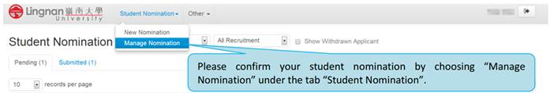
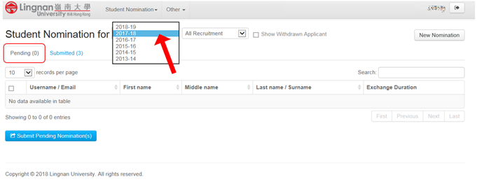
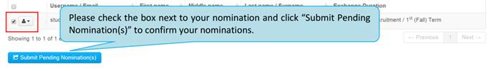

Online System for Student Application
Upon the submission of your online nominations, the nominated students will be invited to complete their applications via the online application system for Student Exchange Programme. They will receive an individual email providing a hyperlink, username and password to get access to the system.

User guides for applicants (including an important note to applicants, a tentative schedule for Summer Term 2018 and a list of required documents): http://www.ln.edu.hk/oge/download/UserGuidesforStudents.pdf

Other Application Materials:
Application Guide: http://www.ln.edu.hk/summer/doc/NonLU_Guide2018.pdf
Fact Sheet of Lingnan: http://www.ln.edu.hk/oge/download/fastfactsheet-summer2018.pdf

VISA/ENTRY Permit Application Form: http://www.immd.gov.hk/pdforms/ID995A.pdf
Guidance Notes on Visa Application:
English version: http://www.immd.gov.hk/pdforms/ID(E)996.pdf
Chinese version: http://www.immd.gov.hk/pdforms/ID(C)996.pdf

Application to Lingnan
Interested students are advised to complete both the Online Application Form (with endorsement from home institution in a printed copy) and the VISA/ENTRY Permit Application Form and return the paper forms along with all requested documents via your office by international courier to the following address by the application deadlines as mentioned above:

Attn: Ms. Christine CHOI
Office of Global Education
AD208/1, Wong Administration Building
Lingnan University, Tuen Mun,
Hong Kong

Other Information:
For information about our Student Exchange Programmes (e.g accommodation, application procedures, FAQ etc.) or general information about life in Lingnan/Hong Kong, you may refer your students to visit http://www.ln.edu.hk/oge/ (under the “Incoming Students” Section).

We would be most grateful if you would promote it among your students. Should you have any questions regarding the Summer Exchange Programme, please visit www.ln.edu.hk/oge or contact us by email to exchange@LN.edu.hk.
Warmest Regards,
Office of Global Education (OGE)
Lingnan University

