Appendices

附件

Appendix 1: Letter of Invitation Template

附件1：邀请函模板

School of Foreign Languages
South China University of Technology
Tel: 020-
Fax: 020-
December 15, 2015
Letter of Invitation

Dear Professor/Mr./Ms.,

It is with great pleasure that I extend this invitation to you to visit South China University of Technology, China, from March 5 to April 10, 2016. The aim of your visit is to discuss scientific paper writing with SCUT faculties and students, and the current schedule of your forthcoming visit contains 3 lectures and a seminar.
Date | Arrangement
March 5 | Arrival
March10-April 5 | Lectures “How to Write a Scientific Paper”
April 9 | Seminar ***
…….

Please find your personal information indicated below:

Full name Gender Date of Birth Nationality Passport No. Title/Position

Your accommodation as well as your flight tickets will be covered by SCUT. We are looking forward to receiving you. Please feel free to contact me if you have any questions or concerns.

Yours sincerely,

Prof.
(Position)
School of
South China University of Technology
381 Wushan Road, Tianhe, Guangzhou,
Guangdong, P. R. China

邀请函

尊敬的 教授/先生/女士：
我荣幸地代表华南理工大学邀请您于2016年3月5日至4月10日访问我校。
您的此次访问包括三场讲座与一次研讨会，将与我校师生共同探讨学术论文写作的相关问题。我校将提供外专公寓并报销来回程国际机票。我殷切期盼与您会面，如您有任何问题请与我联系。
您的个人信息如下：
姓名 性别 出生日期 国籍 护照号 职称/职务

日程安排
3月5日 | 抵达
3月10日-4月5日 | 讲座
4月9日 | 研讨会

华南理工大学 学院（公章）
年 月 日

Appendix 2: CV Template for F Visa

附件2：外专简历模板（访问签证用）

外专简历
姓（如护照所示） |  | 出生日期 |  | 照片  （JPG格式且大小不超过200k）
 |  | 性别
名（如护照所示） |  | 国籍
婚姻状况 |  | 最高学位
护照号码 |  | 电子邮箱
主要教育经历（从本科起）
主要工作经历
主要成就
备注

CV
Surname |  | Date of Birth |  |  |  | Photo  (JPG format and less than 200k in size)
 |  | Gender
Given name(s) |  | Nationality
Marital Status |  | Highest Degree
Address and phone number abroad
Passport number |  |  | Email
Education Background (from undergraduate level)
Work Experience
Major Achievements (incl. awards)
Notes

Appendix 3: Declaration of No Criminal Record Template

附件3：无犯罪记录承诺书模板

无犯罪记录承诺书

广东省外国专家局：
本人 （国籍： 护照号： ），在此郑重承诺，在本国及境外无犯罪记录。来华后将严格遵守中国的法律法规，自觉服从邀请单位各项管理制度。
特此承诺。

Declaration of No Criminal Record

Administration of Foreign Experts Affairs of Guangdong Province：
I, full name (Nationality: Passport Number: ), solemnly declare that I have no criminal record in both my home country and abroad. After my arrival in China, I shall strictly abide by the Chinese laws and regulations, and obey the rules of the host institution.

签名Signature：
时间Date：

Appendix 4: Application for Foreign Experts Invitation

附件4：外国专家来华邀请函申请表

外国专家来华邀请函申请表
APPLICATION FOR FOREIGN EXPERTS INVITATION
姓（如护照所示）  SURNAME (as in Passport) |  | 名（如护照所示）GIVEN NAME(S) (as in Passport) |  | 别名或曾用名（英文）  OTHER ALIAS OR FORMER NAMES
中文姓名CHINESENAME |  | 性别  GENDER |  | 国籍  NATIONALITY
出生日期DATE OF  BIRTH |  | 婚姻状况MARITALSTATUS |  | 最高学位（学历）HIGHESTACADEMIC DEGREE
护照类型PASSPORT  TYPE |  | 护照号码  PASSPORT NUMBER |  | 护照签发日期DATE OF ISSUE
护照有效期至  DATE OF EXPIRY |  | 工作单位  EMPLOYER |  | 在中国工作联系电话  WORK TELEPHONENUMBER IN CHINA
在中国工作邮箱  EMAIL ADDRESS |  | 拟入境次数INTENTEDNUMBER OF ENTRIES |  | 团队人数  NUMBER OF GROUP MEMBERS
经费来源  SOURCE OF FUNDS |  | 金额  AMOUNT OF FUNDS |  | 申请在华工作时间  INTENTED LENGTH OFTIME WORKING IN CHINA
工作日程
WORK SCHEDULE
用人单位承诺如实向行政机关提交有关材料和反映真实情况，并对申请材料实质内容的真实性负责，承担相关法律责任。
THE EMPLOYER HEREBY DECLARES THAT ALL THE DOCUMENTS AND INFORMATION SUBMITTED TO THE AUTHORITY ARE TRUE, AND SHALL BE RESPONSIBLE FORTHE AUTHENTICITY OF THE DOCUMENTS AND UNDERTAKE CORRESPONDING LEGAL RESPONSIBILITIES.
用人单位公章 SEAL OF EMPLOYER
日期 DATE (yyyy-mm-dd)

Appendix 5: Official Letter to the Division of Exit & Entry Administration Template

附件5：给广州市公安局出入境管理支队的公函模板

华南理工大学关于申请F字签证延期/换发的函

广州市公安局出入境管理支队:
兹有 女士/先生 （护照号码： 出生日期： ）为我校学院邀请的外专，来访时间日期为，来访期间的任务包括 。
请准予办理F字签证延期/F字签证换发手续为盼。

本院校保证所提供申请资料真实有效，保证上述人员在我校工作期间严格遵守中国各项法律规定，并在签证有效期内按期离境，否则愿意承担一切相关法律责任。

华南理工大学 学院（公章）
年 月 日

联系人：电话：020-

Appendix 6: CV Template for R Visa

附件6：外专简历模板（人才签证用）
外专简历
姓（如护照所示） |  | 出生日期 |  | 照片  （JPG格式，白底照，大小5M以下）
 |  | 性别
名（如护照所示） |  | 职务
国外单位 |  | 国外电话
电子邮箱 |  | 国外住址
聘用开始时间 |  | 聘用结束时间
主要教育经历（从本科填起，包括毕业学校、所读专业、学位、开始和结束时间）
主要工作经历（包括单位名称、所在国家、工作岗位、职务、任务、开始和结束时间）
随行家属信息（包括家属姓名、性别、国籍、护照号、与申请人关系，无随行家属不填）
个人专长
代表性成果
获奖情况

CV
Surname (as on passport) |  | Date of Birth |  | Photo  (White background, JPG format and less than 5MB in size)
 |  | Gender
Given name (as on passport) |  | Position/Title
Current employer abroad |  | Phone number abroad
Email |  | Address abroad
Starting and ending dates of employment in China
Education Background from undergraduate level (Including the names of your universities, majors, time of start and graduation)
Work Experience (Including name of the company or institution, country, position, title, duty and duration of employment )
Accompanying family members (Including name, gender, nationality, passport number and relationship).
Expertise
Main Accomplishments
Awards

Appendix 7: Criteria for Guangdong High-Level Foreign Experts

附件7：广东省外籍高层次人才认定标准
（摘自粤外专规【2017】1号文件）

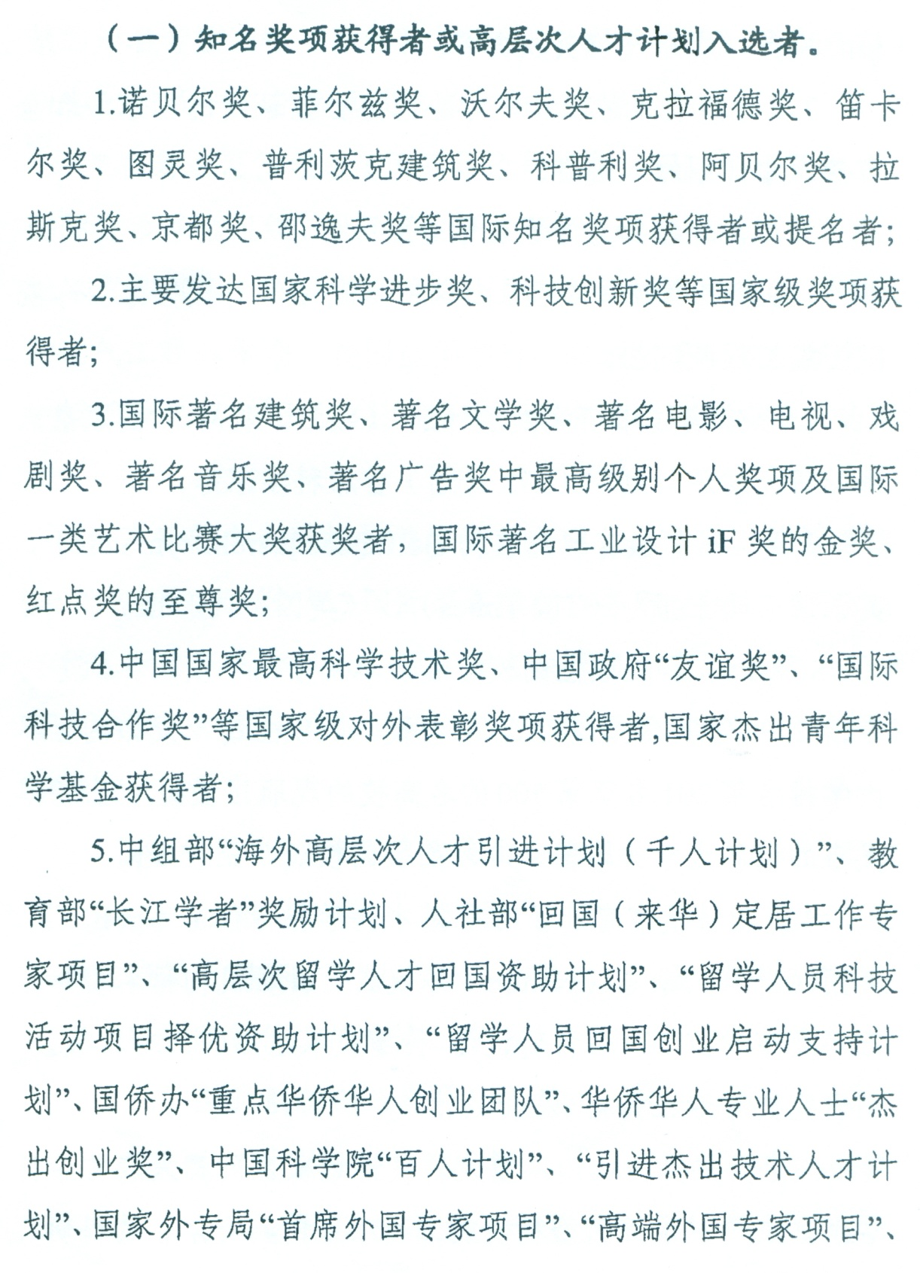

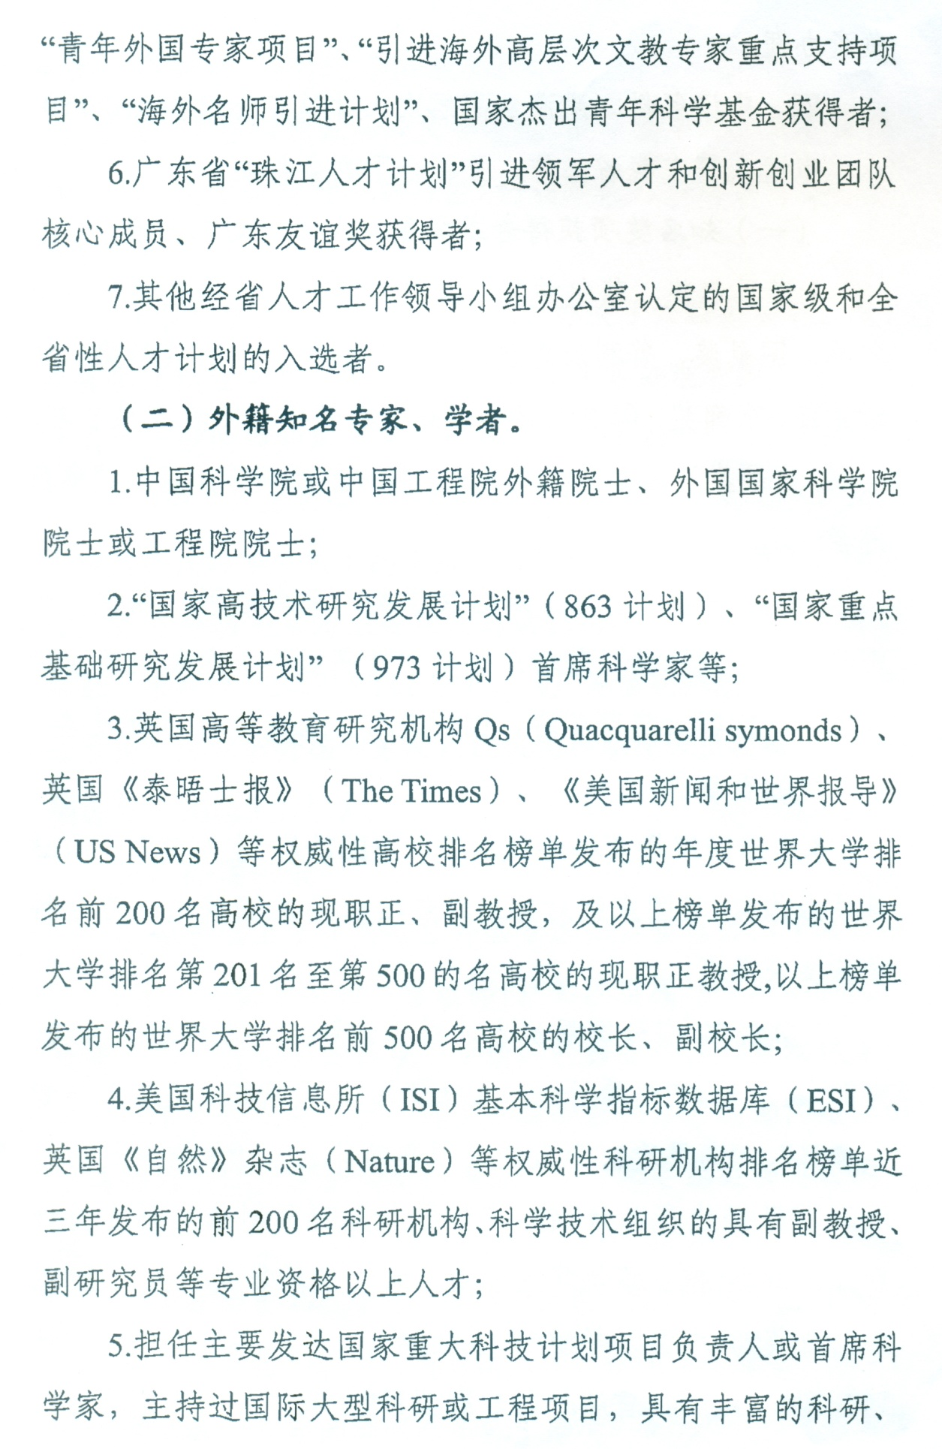

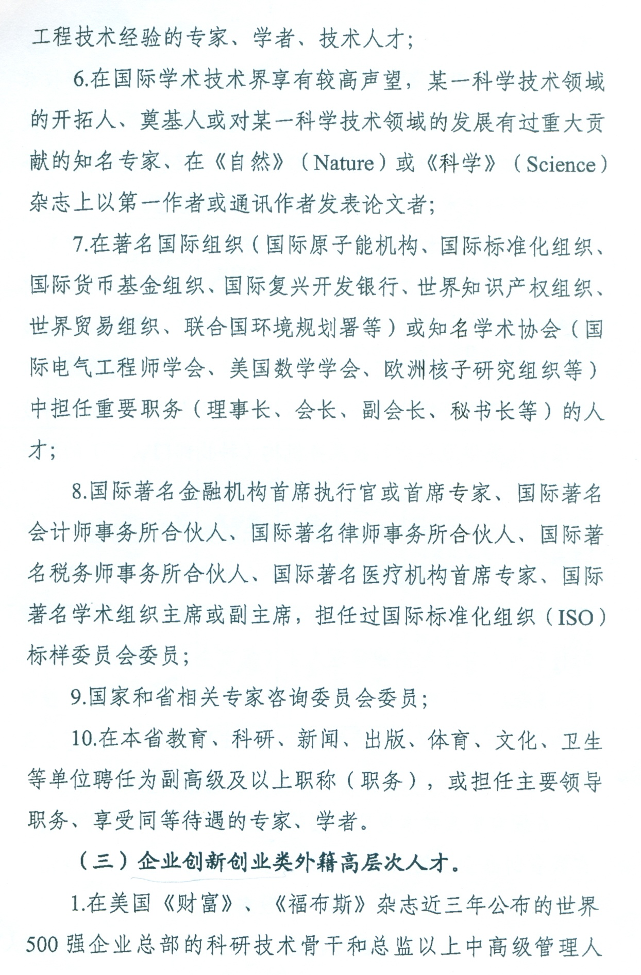
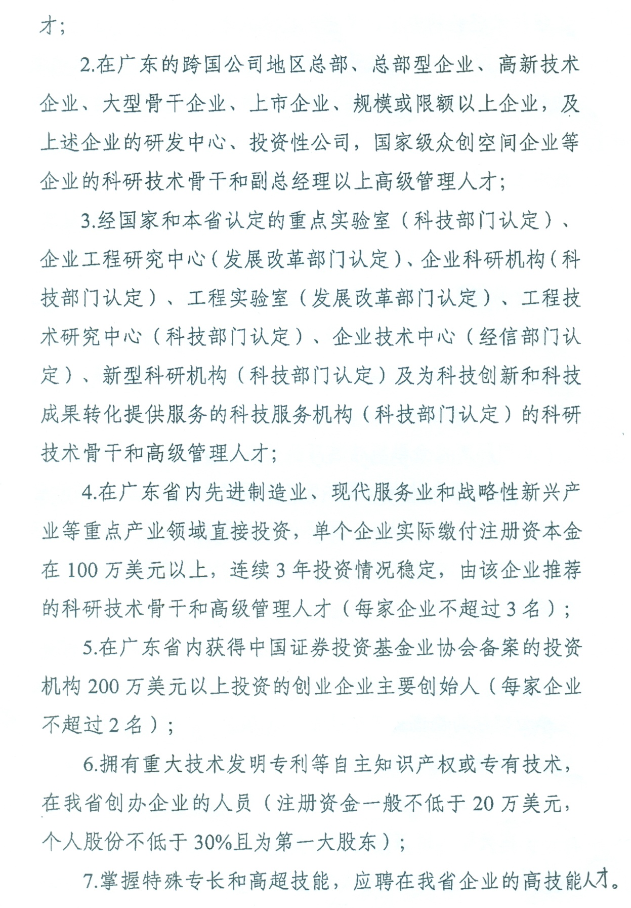

Appendix 8: GDAFEA’s Letter of Confirmation for High-Level Foreign Experts

附件8：广东省外籍高层次人才确认函

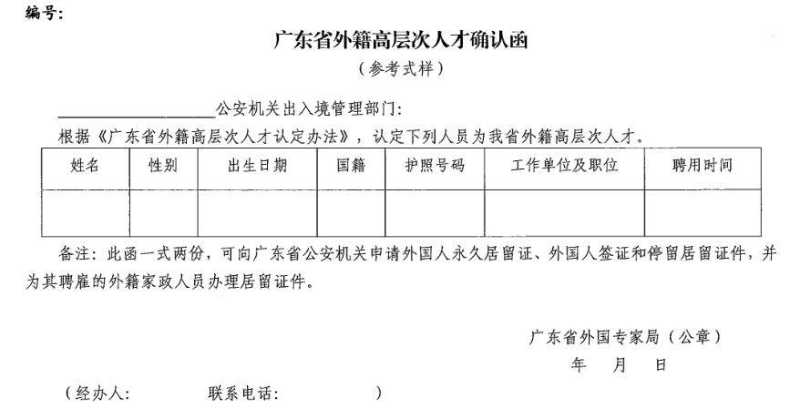

Appendix 9: Division of Exit &Entry Administration of Guangzhou Municipal Public Security Bureau and Service Center of Public Security Bureau of Tianhe District

附件9：广州市公安局出入境管理支队和天河区公安分局综合办证中心相关信息

Division of Exit &Entry Administration of Guangzhou Municipal Public Security Bureau
广州市公安局出入境管理支队相关信息
- Address: Exit & Entry Administration Division, Guangzhou Municipal Public Security Bureau, 5-6th Floor, Entry & Exit Building, No.155, Jiefangnan Lu Road; (Take a waiting list ticket and submit your documents the 5th floor, after which you’ll have interview on the 6th floor);  - Business hours:  8:30-12:00, 14:00-17:30, Monday to Friday;  - Tel: 96110110 or 12345;  - For visa fee information, please check http://www.gzjd.gov.cn/gzjdw/wsbs/bszn/crj_bszn/wgr/index.shtml | - 地址：越秀区解放南路155号出入境大厦5-6楼，广州市公安局出入境管理支队（5楼领取等候号及提交材料，6楼面试）  - 办理时间：  周一至周五8:30-12:00，14:00-17:30  - 咨询电话：96110110或12345  - 收费标准请见金盾网办事指南：http://www.gzjd.gov.cn/gzjdw/wsbs/bszn/crj_bszn/wgr/index.shtml
Service Center of Public Security Bureau of Tianhe District
天河区公安分局综合办证中心相关信息
- Address: 2nd Floor, Government Service Center, No.13, Ruanjian Lu Road, Tianhe District  - Business hours:  9:00-12:00, 13:00-17:00 Monday to Thursday; 9:00-12:00, 13:00-15:00 Friday;  - Tel: 020-37690314 | - 地址：天河区软件路13号天河区政务服务中心2楼  - 办理时间：  周一至周四上午9:00-12:00，下午13:00-17:00；周五上午9:00-12:00，下午13:00-15:00  - 咨询电话：020-37690314

