附录A / Appendix A
Sweet Memories of the Doctoral Consortium of SEDSLIMSS
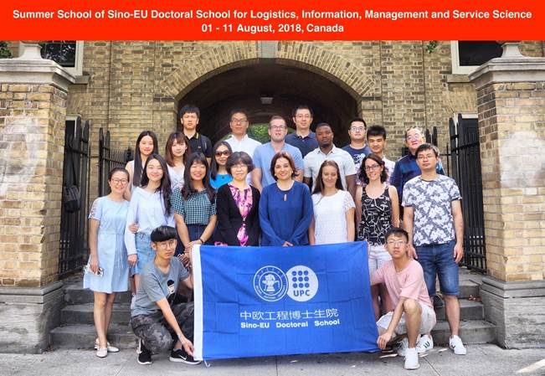
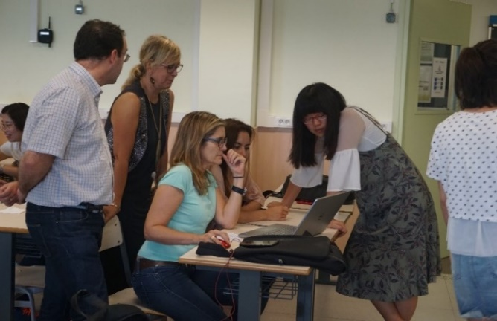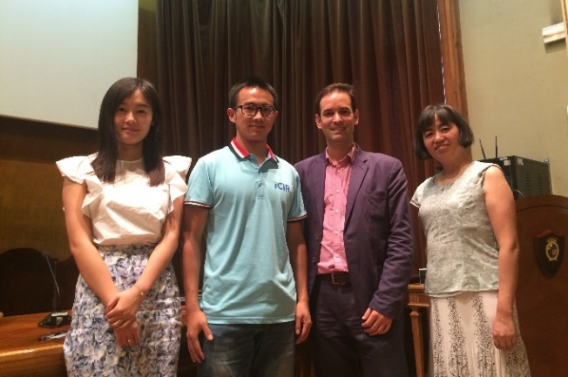
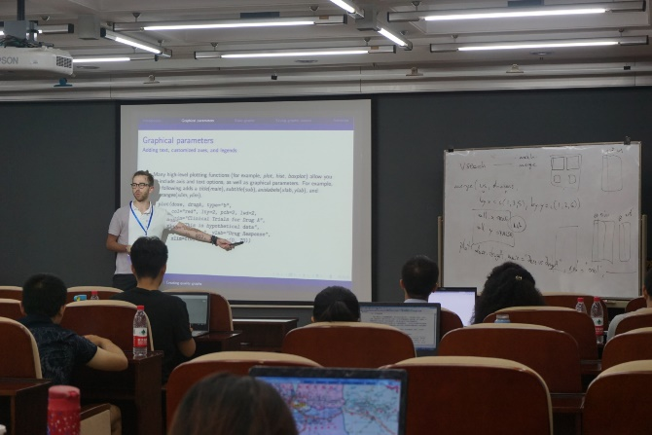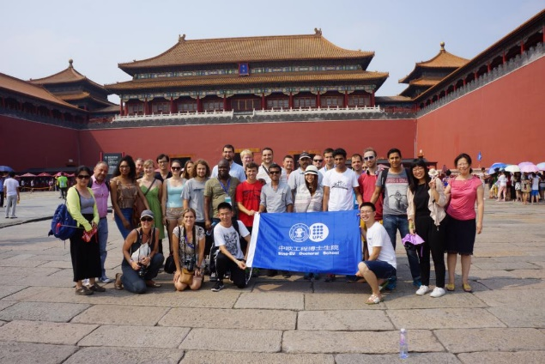

附录B / Appendix B
2022年博士生暑期学校详细行程
日期 | 时间  (北京时间) | 活动  （线上+线下）
7/20/2022 | 9:00-12:00 | 线下注册登记
 | 12:00-13:00 | 午餐
 | 13:00-16:30 | 线下注册登记
 | 17:00-20:00 | 晚餐
7/21/2022 | 9:00-9:30 | 中欧博士生院暑期学校开幕式 (线上+线下)
 | 9:30-11:00 | 教授授课 (线上)  演讲嘉宾：Professor Gautam Kamath, University of Waterloo  题目：Private machine learning
 | 11:10-12:00 | 学生自我介绍及破冰游戏 (线上+线下)
 | 12:00-14:00 | 休息
 | 14:00-22:00 | LISS 2022和IEIS 2022大会开幕式 (线上)  LISS 2022和IEIS 2022大会主题演讲 (线上)
7/22/2022 | 9:00-11:00 | LISS 2022和IEIS 2022大会主题演讲 (线上)
 | 12:00-14:00 | 休息
 | 14:00-15:00 | 交大评论《我国网信产业链短板环节及自主创新白皮书》发布会 (线上+线下)  邀请嘉宾：张宏科院士，北京交通大学
 | 15:30-17:00 | 博士生分组学术交流研讨会 (线上+线下)
 | 17:00-18:00 | 休息
 | 18:00-22:00 | LISS 2022和IEIS 2022闭幕式 (线上)
7/23/2022 | 9:00-10:30 | 教授授课 (线上)  演讲嘉宾：Professor Robin Qiu,  The Pennsylvania State University
 | 10:40-12:00 | 主题研讨会 (线上)  题目：从博士生到青年老师的打怪升级之路  邀请嘉宾：青年教师，往届暑期学校优秀学员  陈东华（对外经贸大学）、向杰（四川大学）、张一（物资学院）、王军（北京化工大学）、张名扬（北京林业大学）、王艾（北京科技大学）
 | 12:00-14:00 | 休息
 | 14:00-15:30 | 企业讲座 (线上)
 | 15:40-18:00 | 博士生分组学术交流研讨会 (线上+线下)
7/24/2022 | 9:00-10:30 | 企业讲座 (线上)
 | 10:40-12:00 | 主题研讨会 (线上)
 | 12:00-14:00 | 休息
 | 14:00-15:30 | 企业讲座 (线上)
 | 15:40-18:00 | 博士生分组学术交流研讨会 (线上+线下)
7/25/2022 | 9:00-10:30 | 教授授课 (线上)  演讲嘉宾：Professor Sylvia Gao, University of Auckland  题目：How to do quant research?
 | 10:40-12:10 | 教授授课 (线上)
 | 12:10-14:00 | 休息
 | 14:00-15:30 | 教授授课 (线上)  巴塞罗那加泰罗尼亚理工大学
 | 15:40-18:00 | 博士生分组学术交流研讨会 (线上+线下)
7/26/2022 | 9:00-10:30 | 教授授课 (线上)  演讲嘉宾：Professor Xinghua Zhang,  Beijing Jiaotong University
 | 10:40-12:10 | 教授授课 (线上)
 | 12:10-14:00 | 休息
 | 14:00-15:30 | 教授授课 (线上)  巴塞罗那加泰罗尼亚理工大学
 | 15:40-16:40 | 博士生分组学术交流研讨会 (线上+线下)
 | 17:00-18:00 | 毕业典礼 (线上+线下)

Program of the 2022 doctoral consortium
Date | Time  (GMT+8) | Activities  （Online+On-site）
7/20/2022 | 9:00-12:00 | Registration
 | 12:00-13:00 | Lunch
 | 13:00-16:30 | Registration
 | 17:00-20:00 | Dinner
7/21/2022 | 9:00-9:30 | Opening ceremony (Virtual + On-site)
 | 9:30-11:00 | Masterclass (Virtual)  Guest speaker: Professor Gautam Kamath, University of Waterloo  Topic：Private machine learning
 | 11:10-12:00 | Student self-introduction and ice-breaker
 | 12:00-14:00 | Break
 | 14:00-22:00 | LISS 2022 and IEIS 2022 Conference opening ceremony (Virtual)  Keynote speeches in LISS 2022 and IEIS 2022 (Virtual)
7/22/2022 | 9:00-11:00 | Keynote speeches in LISS 2022 and IEIS 2022 (Virtual)
 | 12:00-14:00 | Break
 | 14:00-15:00 | "White Paper on Short Links and Independent Innovation of Chinese Internet Information Industry Chain" from Jiaotong University Review Release Announcements (Virtual + On-site)  Invited guest: Professor Hongke Zhang, Academician, Beijing Jiaotong University
 | 15:30-17:00 | Doctoral student group seminar (Virtual + On-site)
 | 17:00-18:00 | Break
 | 18:00-22:00 | LISS 2022 and IEIS 2022 Conference closing ceremony (Virtual)
7/23/2022 | 9:00-10:30 | Masterclass (Virtual)  Guest speaker：Professor Robin Qiu, The Pennsylvania State University
 | 10:40-12:00 | Panel Talk (Virtual)  Topic: The transformation from doctoral students to young faculties.  Invited guests: young faculties from outstanding students of previous summer schools  Donghua Chen (University of International Business and Economics), Jie Xiang (Sichuan University), Yi Zhang (School of Materials and Materials), Jun Wang (Beijing University of Chemical Technology), Mingyang Zhang (Beijing Forestry University), Ai Wang (Beijing University of Science and Technology)
 | 12:00-14:00 | Break
 | 14:00-15:30 | Corporate senior leadership seminar (Virtual)
 | 15:40-18:00 | Doctoral student group seminar (Virtual + On-site)
7/24/2022 | 9:00-10:30 | Corporate senior leadership seminar (Virtual)
 | 10:40-12:00 | Panel Talk (Virtual)
 | 12:00-14:00 | Break
 | 14:00-15:30 | Corporate senior leadership seminar (Virtual)
 | 15:40-18:00 | Doctoral student group seminar (Virtual + On-site)
7/25/2022 | 9:00-10:30 | Masterclass (Virtual)  Guest speaker：Professor Sylvia Gao, University of Auckland  Topic：How to do quant research?
 | 10:40-12:10 | Masterclass (Virtual)
 | 12:10-14:00 | Break
 | 14:00-15:30 | Masterclass (Virtual)  Universitat Politècnica de Catalunya Barcelona Tech
 | 15:40-18:00 | Doctoral student group seminar (Virtual + On-site)
7/26/2022 | 9:00-10:30 | Masterclass (Virtual)  Guest speaker：Professor Xinghua Zhang,  Beijing Jiaotong University
 | 10:40-12:10 | Masterclass (Virtual)
 | 12:10-14:00 | Break
 | 14:00-15:30 | Masterclass (Virtual)  Universitat Politècnica de Catalunya Barcelona Tech
 | 15:40-16:40 | Doctoral student group seminar (Virtual + On-site)
 | 17:00-18:00 | Closing ceremony (Virtual + On-site)

