A great chance of international exchange is coming!

Summer School of Sino-EU Doctoral School for Logistics, Information, Management, and Service Science

Introduction
The summer school of Sino-EU Doctoral School for Logistics, Information, Management and Service Sciences (SEDSLISS) is one of work from SEDSLISS between Universitat Politècnica de Catalunya Barcelona Tech (UPC) and Beijing Jiaotong University (BJTU) to promote discipline integration and innovate doctoral training in engineering, with the advantages of both Universitat Politècnica de Catalunya Barcelona Tech (UPC) and Beijing Jiaotong University (BJTU) in fields of logistics and management science.
The summer school, having been through 3 successful consecutive times (see Appendix A), aims to establish a platform of international academic exchange on the cutting edge of logistics, information, management and service sciences, by providing the participants with top academic lectures, varieties of seminars, multicultural experience, etc.

Key information of the summer school in 2018
- Scope: Cutting edge of logistics, information, management and service sciences
- Program: See appendix B
- Time: August 2 - 11, 2018
- Place: University of Toronto (2-6 Aug.) and University of Vancouver (7-11 Aug.), Canada
- Sponsor: Beijing Jiaotong University, UPC
- Co-organizer: University of Toronto

Additional Benefit
- All the participants enjoy a free access to the keynote speeches and regular workshops of two international conferences (LISS’2018 and IEIS’2018), thanks to the established agreements between the summer school and the committees of LISS’2018 and IEIS’2018, which would enable participants to closely touch the cutting-edge thoughts of distinguished masters and develop deep communication with them.

Enrollment Targets and Requirement
- Enrollment targets: Full-time Ph. D students
- Requirement:
- The applicants are limited to those focusing on topics in the fields (or intersectional fields) of logistics and supply chain, information management and system, management science and engineering.
- The applicant should submit an abstract describing his work for exchange.
- Every applicant is expected to give a 40-50 minute talk on his recent innovative work in the summer school seminars.

Attractive Preferential Treatment
- Beijing Jiaotong University provides the participants with a generous exemption of the total accommodation expense, i.e., the food and hotel cost.
- The participants only need to pay the travel cost for themselves.

Contact Information
- Contact: Dr. Jun Wang, 14113149@bjtu.edu.cn

Appendix A

Some Sweet Memories of the Summer School of SEDSLISS
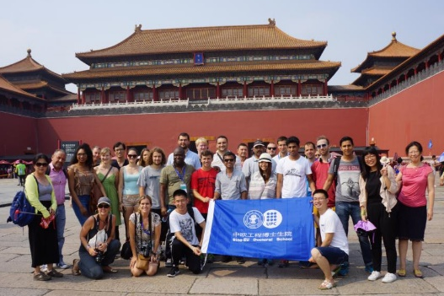
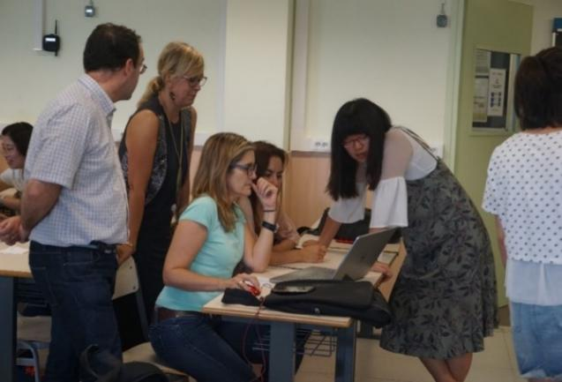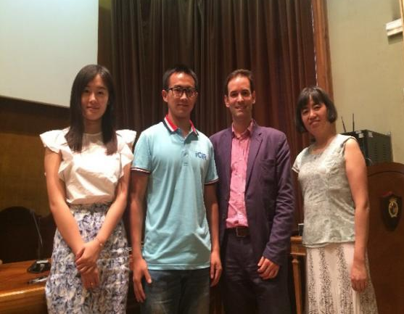
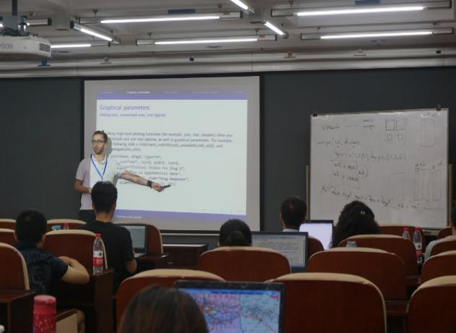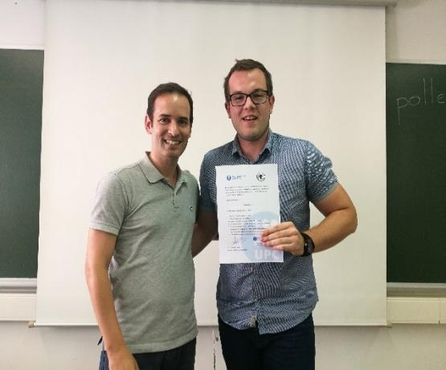

Appendix B

Program of the summer school in 2018
 | Date | Time | Activity
Toronto | 8/02/2018 | 8:00-9:00 | Registration
 |  | 9:10-9:30 | Open ceremony
 |  | 9:40-11:40 | Lecture from Lecture from University of Toronto
 |  | 11:50-14:00 | Break
 |  | 14:00-16:00 | Lecture from UPC
 | 8/03/2018 | 9:00-11:00 | Outdoor activity of University of Toronto
 |  |  | Free time
 | 8/04/2018 | 9:00-11:30 | Lectures in LISS 2018 and IEIS 2018
 |  | 11:30-14:00 | Break
 |  | 14:00-18:00 | Lectures in LISS 2018 and IEIS 2018
 | 8/05/2018 | 9:00-11:30 | Lectures in LISS 2018 and IEIS 2018
 |  | 11:30-14:00 | Break
 |  | 14:00-18:00 | Lectures in LISS 2018 and IEIS 2018
 | 08/06/2018 | 9:00-11:30 | Students Presentation
 |  |  | Fly to Vancouver
Vancouver | 8/07/2018 | 9:00-11:30 | Lecture from University of British Columbia
 |  | 11:30-14:00 | Break
 |  | 14:00-16:00 | Students Presentation
 | 8/08/2018 | 9:00-11:30 | Lecture from Beijing Jiaotong University
 |  | 11:30-14:00 | Break
 |  | 14:00-16:00 | Culture Communication with University of Vancouver
 | 8/09/2018 | 9:00-11:30 | Lecture from Beijing Jiaotong University
 |  | 11:30-14:00 | Break
 |  | 14:00-16:00 | Outdoors Activity of University of Vancouver
 | 8/10/2018 |  | Free time
 | 8/11/2018 | 9:00-11:30 | Close session
 |  |  | Free time

